Name Date
Practice A
9.5
Find the volume of the pyramid.
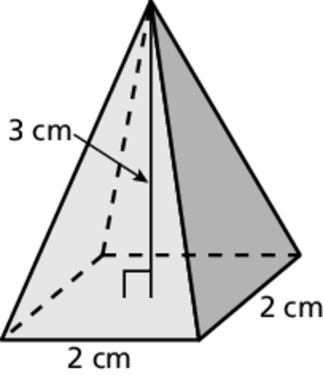
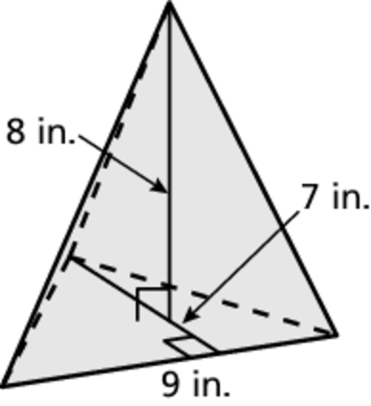
1. 2.
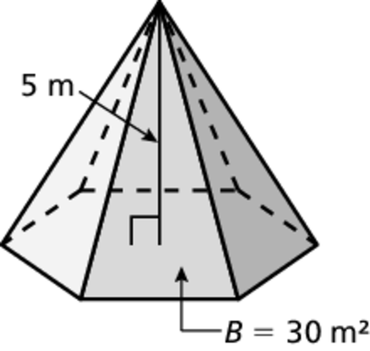
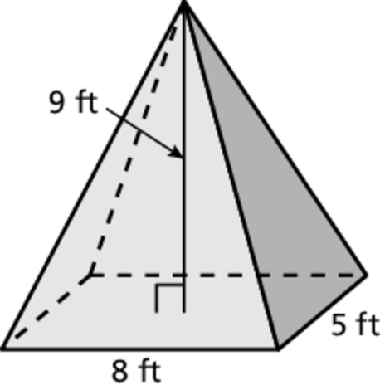
3. 4.
5. A tent is in the shape of a pyramid. The base is a rectangle with a length
of 12 feet and a width of 10 feet. The height of the tent is 8 feet. Find the volume of the tent.
6. A sign made of solid wood is in the shape of a pyramid. The base is a triangle with a base of 6 feet and a height of 4 feet. The height of the sign
is 7 feet. The wood costs $3 per cubic foot. What is the cost of the sign?
7. Two pyramids with square bases have the same volume. One pyramid has
a height of 6 centimeters and the area of the base is 36 square centimeters.
a. What is the volume of the pyramids?
b. The base of the other pyramid has a side length of 3 centimeters. What is the height of this pyramid?
8. How does the volume of a pyramid change when the height is halved?

Name Date
Practice B
9.5
Find the volume of the pyramid.
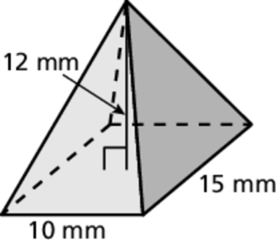
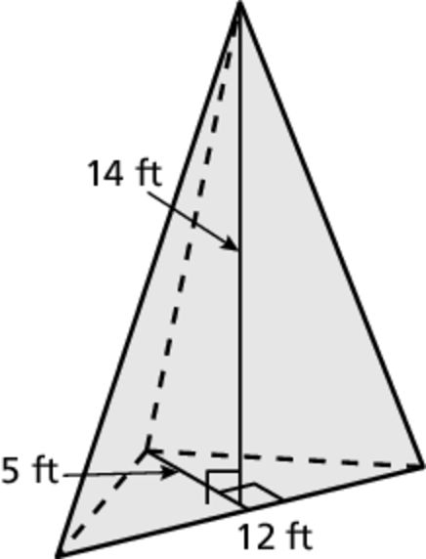
1. 2.
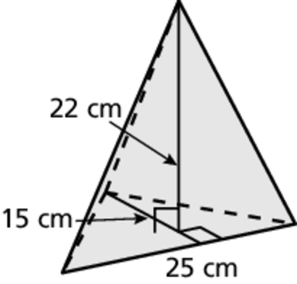
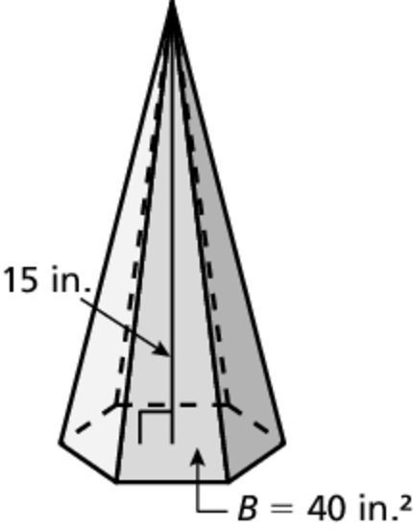
3. 4.
5. A pyramid has a rectangular base with length of 15 feet and a width of 8 feet. The height of the pyramid is 10 feet.
a. Find the volume of the pyramid.
b. When the pyramid was being built, the original base was dropped and it split in two pieces. Each piece was a triangle with a base of 15 feet and a height
of 8 feet. Pyramids were made with these two bases, each with a height of
10 feet. Find the combined volume of the two pyramids.
c. Is the combined volume greater than, less than, or the same as the volume
of the pyramid?

