Name Date

Practice A

9.4

Find the volume of the prism.

1. 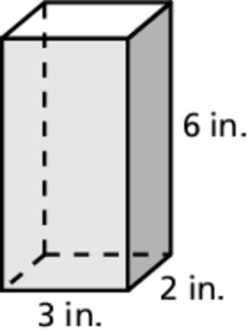 2. 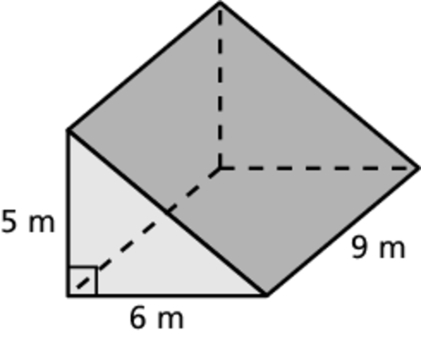

3. 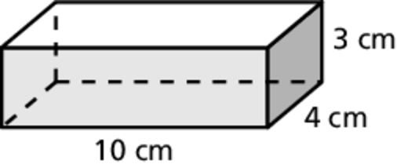 4. 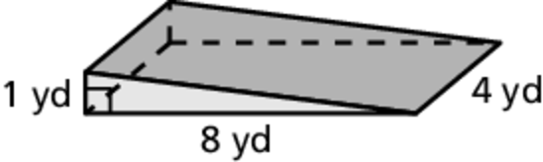

5. 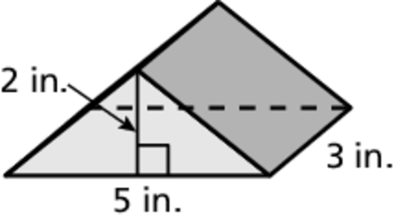 6. 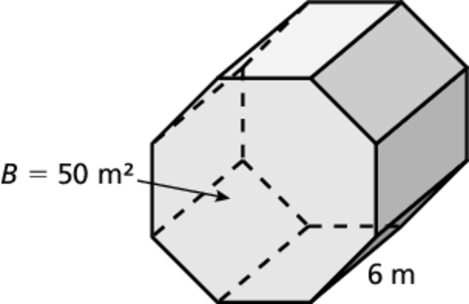

7. A cell phone is in the shape of a rectangular prism, with a length of 4 inches,   
a width of 2 inches, and a height of 1 inch. What is the volume of the cell phone?

8. A recycle bin is in the shape of a trapezoidal prism. The area of the base is 220 square inches and the height is 24 inches. What is the volume of the recycle bin?

9. A water jug is in the shape of a prism. The area of the base is 100 square inches and the height is 20 inches. How many gallons of water will the water jug hold?  Round your answer to the nearest tenth.

Name Date

Practice B

9.4

Find the volume of the prism.

1. 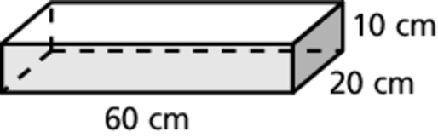 2. 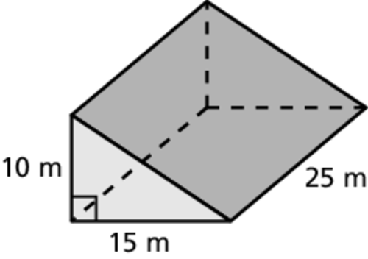

3. 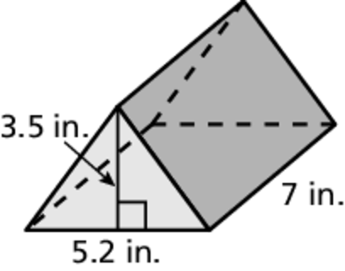 4. 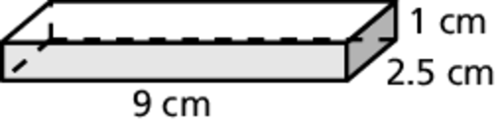

5. 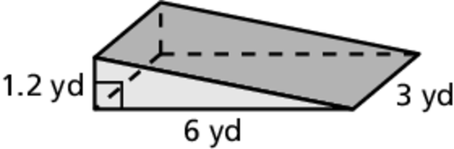 6. 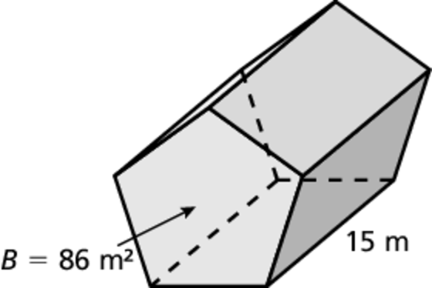

7. A mailbox is in the shape of a prism. The area of the base is 52 square inches and the height is 18 inches. What is the volume of the mailbox?

8. A chicken broth container is in the shape of a rectangular prism, with a length   
of 9.5 centimeters, a width of 6 centimeters, and a height of 16.5 centimeters.   
The container is 90% full. How many liters of chicken broth are in the container?  Round your answer to the nearest hundredth.

9. How many cubic feet are in a cubic yard? Use a sketch to explain your reasoning.