Name Date
Enrichment and Extension
9.4
Brain Buster Boxes
As you work, keep in mind that prisms with the same dimensions in a different order do not count as different prisms. (For example, a rectangular prism that
is 5 inches long, 10 inches wide, and 10 inches tall is the same as a rectangular prism that is 10 inches long, 10 inches wide, and 5 inches tall. The prism has
just been rotated.)
1. Make a list of all the different rectangular prisms you can make using only side lengths of 5 inches, 10 inches, and 15 inches.
a. Find the volume and surface area of each of your prisms.
b. Copy and complete the table by putting the volumes in order from
least to greatest.
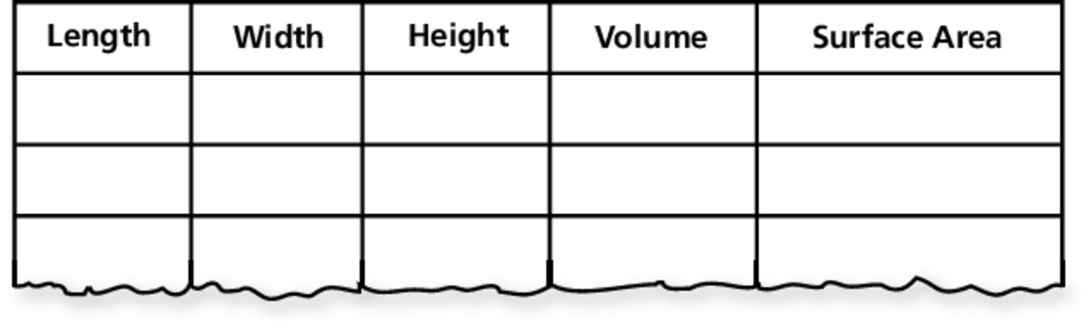

2. Make a list of all the different rectangular prisms you can make using only side lengths of 5 inches, 8 inches, 15 inches, and 50 inches.
a. Find the volume and surface area of each of your prisms.
b. Use a table similar to Exercise 1 part (b) to put the volumes in order from least to greatest.
3. Look at both tables. As the volume increases, describe what happens to the surface area. Describe any patterns that you see.
4. How would you change the dimensions of a rectangular prism box so that
it holds more while using less cardboard to make?

