Name Date

Practice A

9.3

Make a net for the cylinder. Then find the surface area of the cylinder. Round your answer to the nearest tenth.

1. 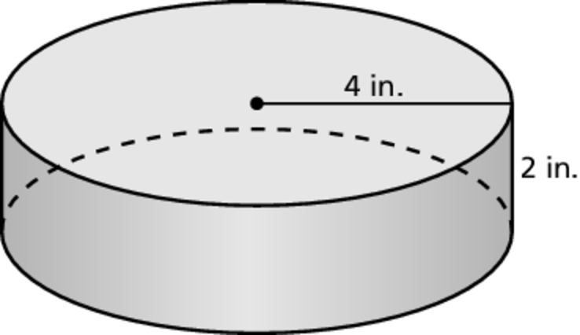 2. 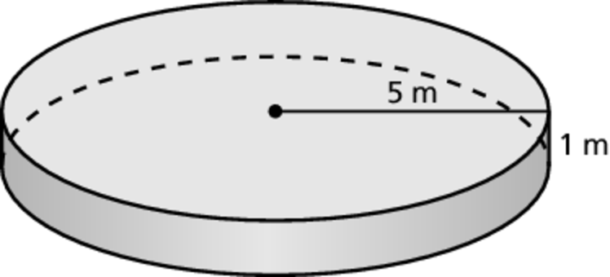

Find the surface area of the cylinder. Round your answer to the   
nearest tenth.

3. 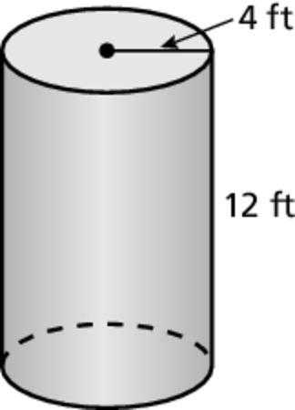 4. 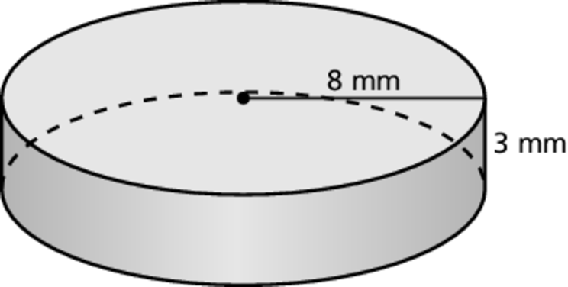

Find the lateral surface area of the cylinder. Round your answer to the nearest tenth.

5. 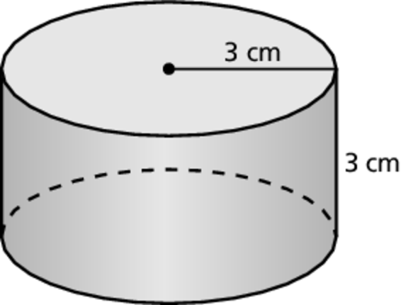 6. 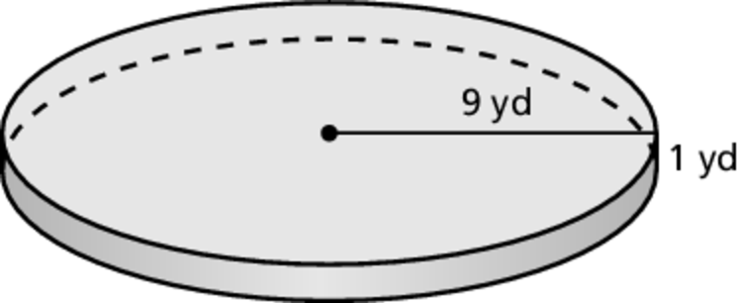

7. A deep dish pizza has a radius of 6 inches and a height of 1 inch. Find the surface area of the pizza. Round your answer to the nearest tenth.

Name Date

Practice B

9.3

Find the surface area of the cylinder. Round your answer to the   
nearest tenth.

1. 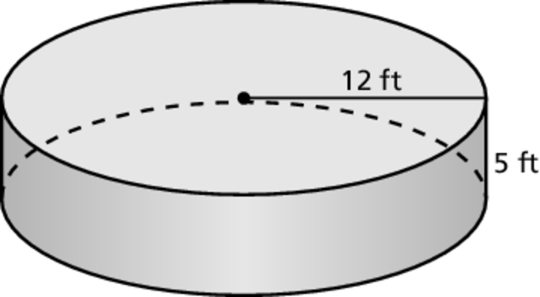 2. 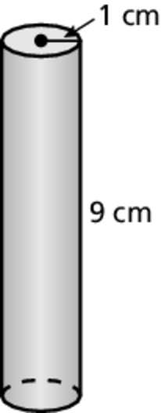

Find the lateral surface area of the cylinder. Round your answer to the nearest tenth.

3. 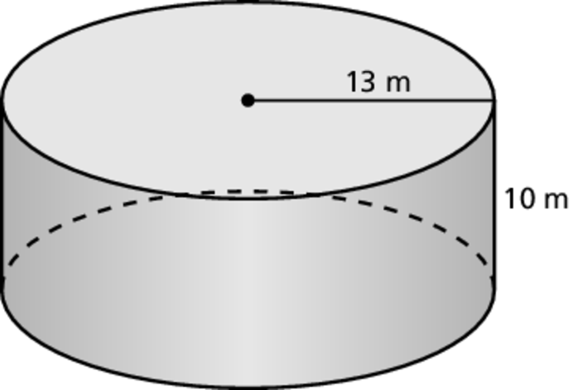 4. 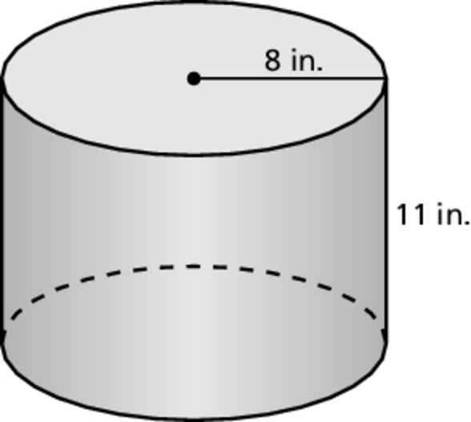

5. A quarter is worth $0.25 and a half dollar is worth $0.50.

a. A quarter has a diameter of  inch and a height of  inch. Find the surface area of a quarter. Round your answer to the nearest hundredth.

b. A half dollar has a diameter of  inches and a height of  inch. Find the surface area of a half dollar. Round your answer to the nearest hundredth.

c. Show that the value of the coin is not proportional to the surface area   
of the coin.

d. If the values of the coins were proportional to the surface areas of the coins, what would be the surface area of the half dollar? Round your answer to the nearest hundredth.