Name Date

Enrichment and Extension

9.3

The Icing on the Cake

Answer the following questions. As you calculate the surface area that icing covers, keep in mind that the bottom of the cake does not get   
any icing.

1. A cylindrical cake is made in a pan that has a diameter of 9 inches and   
a height of inches.

a. What is the total surface area of the cake?

b. The cake is cut into 10 equal-sized wedges. What is the total surface area of the cake now?

c. After the cake is cut, what percent of the cake’s surface is covered   
with icing?

d. Cake does not stay as moist after it has been cut into pieces. Use   
surface area to explain this.

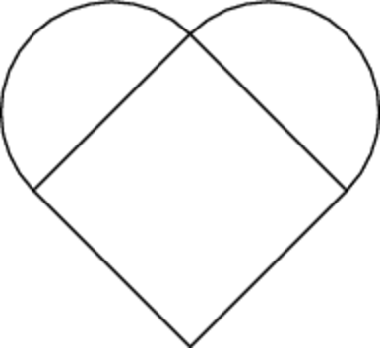 2. José has decided to make a heart-shaped cake using a square pan that   
is 9 inches by 9 inches and a circular pan with a diameter of 9 inches.   
Both pans are  inches tall. The diagram below shows the top view   
of the cake.

a. José knows from experience that one 8-ounce container of icing will cover a cake made from his square pan exactly the way he likes it.   
If he covers his heart-shaped cake the same way, how many ounces   
of icing will he use?

b. How many 8-ounce containers of icing will he have to buy? How much icing will be left over?