Name Date
Practice A
9.2
Use the net to find the surface area of the regular pyramid.
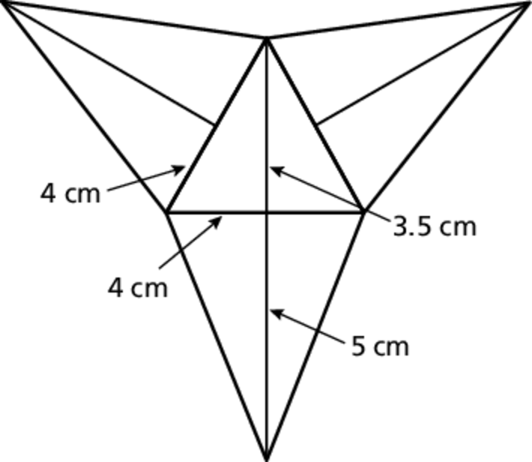
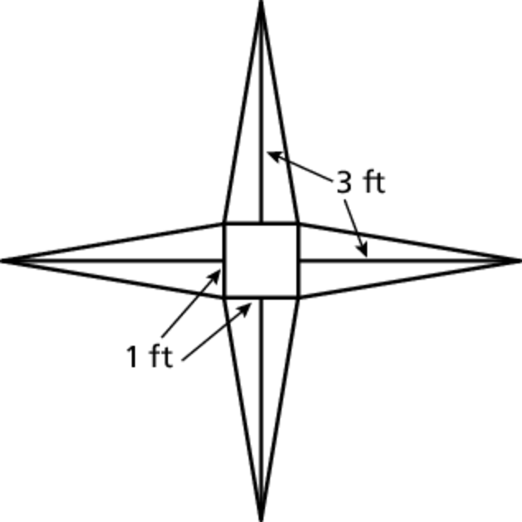
1. 2.
Find the surface area of the regular pyramid.
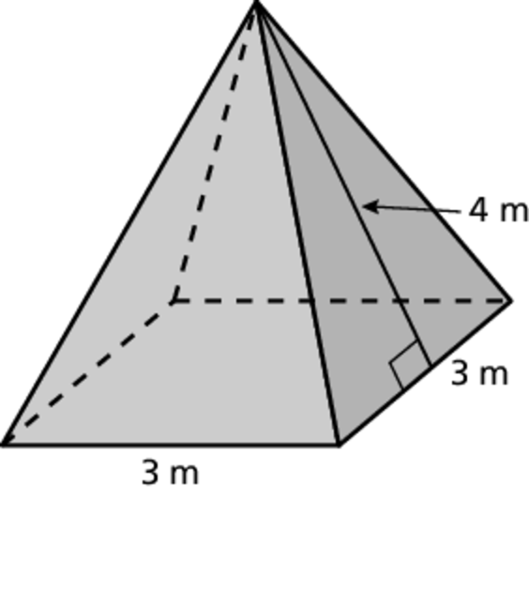
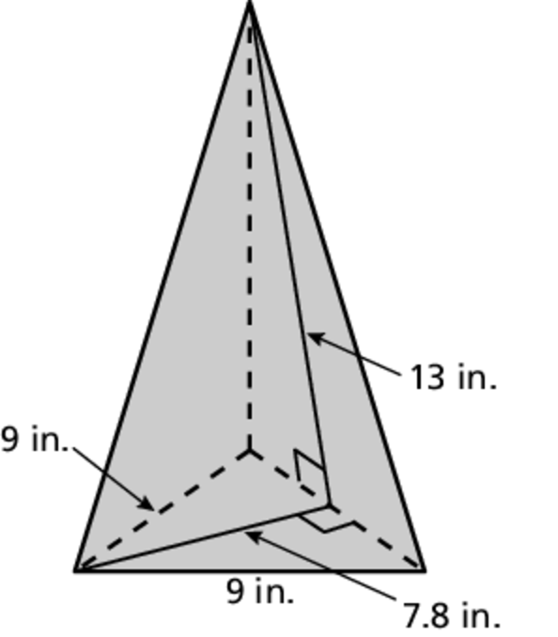
3. 4.
5. Your friend is purchasing an umbrella with a slant height of 4 feet. There are a variety of such umbrellas to choose from.
a. A red umbrella is shaped like a regular pentagonal pyramid with a side length of 3 feet. Find the lateral surface area of the red umbrella.
b. A yellow umbrella is shaped like a regular hexagonal pyramid with
a side length of 2.5 feet. Find the lateral surface area of the yellow umbrella.
c. A blue umbrella is shaped like a regular octagonal pyramid with a side length of 1.9 feet. Find the lateral surface area of the blue umbrella.
d. Based on lateral surface areas, would you suggest that your friend pick the umbrella that is her favorite color? Explain.
Name Date
Practice B
9.2
Find the surface area of the regular pyramid.
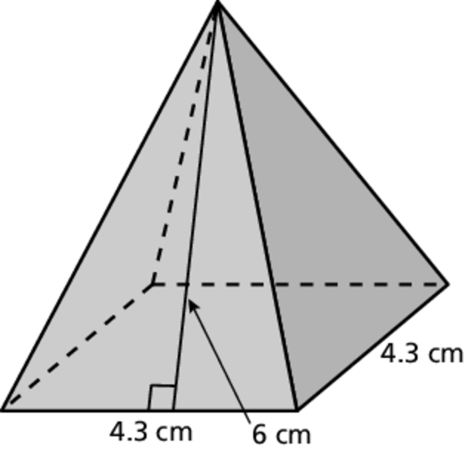
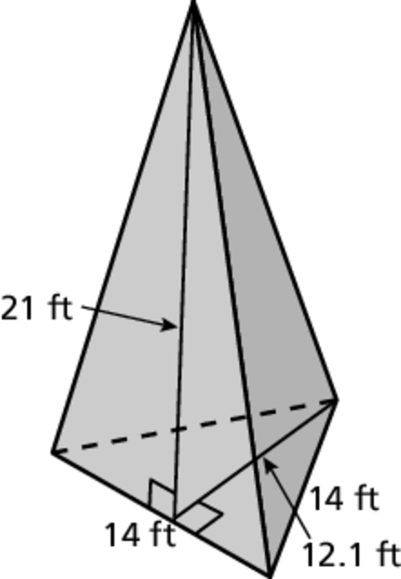
1. 2.
3. Researchers have determined that a hip roof offers the most protection to a house during a hurricane.
a. The house has a square base with a side length of 50 feet. The house has a variation of a hip roof in the shape of a regular pyramid with a square base. The roof extends 1 foot beyond the walls of the house on all sides. What is the length of each side of the base of the roof?
b. The slant height of the roof is 35 feet. Find the sum of the areas of the lateral faces of the pyramid.
c. A metal roof covering offers the most protection to a house during a hurricane. The cost of installing metal roof covering is $350 for every 100 square feet of roof. What is the cost of installing a metal roof covering on the house?
4. The surface area of a regular triangular pyramid is 197.1 square meters. The slant height is 12 meters. The area of the base is 35.1 square meters. The base length is 9 meters. What is the height of the triangular base?
5. The surface area of a regular pentagonal pyramid is 125 square yards. The base length is 5 yards. The area of the base is 37.5 square yards. What is
the slant height of the pyramid?

