Name Date

9.1

puzzle

Puzzle Time

What Did The Little Tire Want To Be When   
He Grew Up?

Answers

H. 

L. 

I. 

B. 

W. 

G. 

A. 

E. 

E. 

Write the letter of each answer in the box containing the   
exercise number.

Find the surface area of the prism.

1. 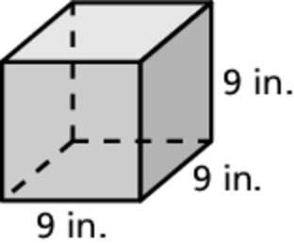 2. 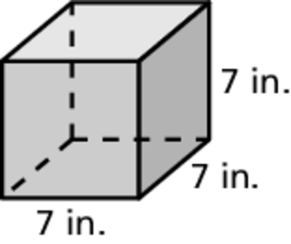

3. 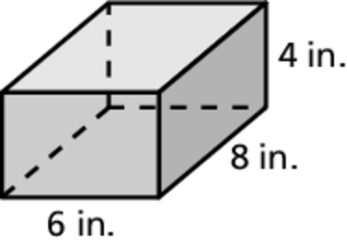 4. 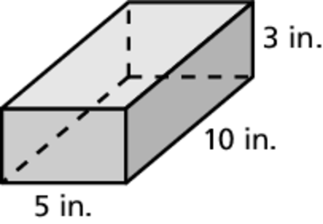

5. 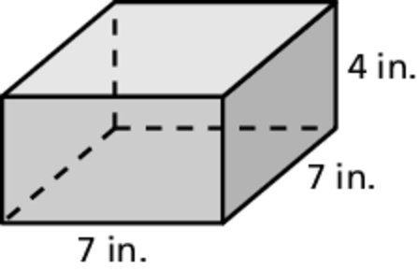 6. 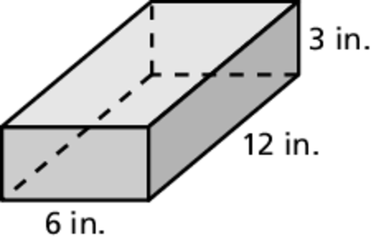

7. 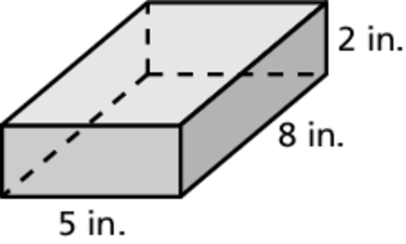 8. 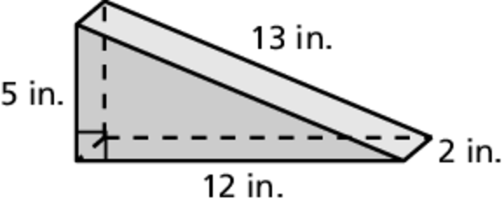

9. 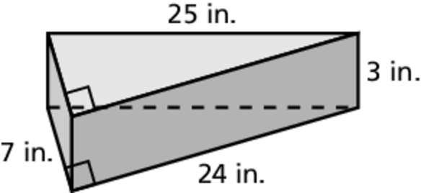

|  |  |  |  |  |  |  |  |  |  |  |
| --- | --- | --- | --- | --- | --- | --- | --- | --- | --- | --- |
| **1** |  | **8** | **5** | **2** |  | **7** | **4** | **9** | **6** | **3** |
|  |  |  |  |  |  |  |  |  |  |  |