Name Date
Practice A
9.1
Find the surface area of the prism.
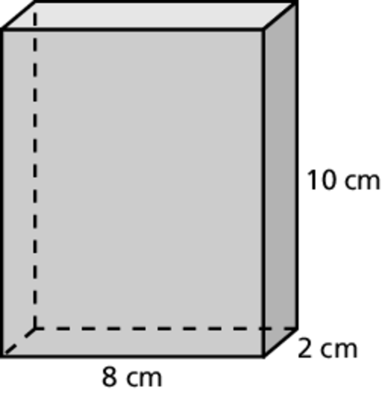
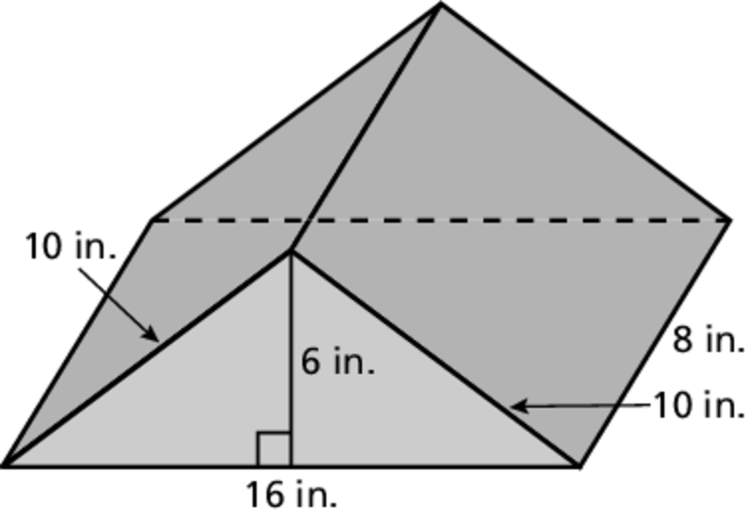
1. 2.
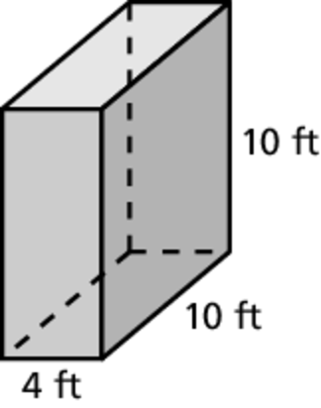
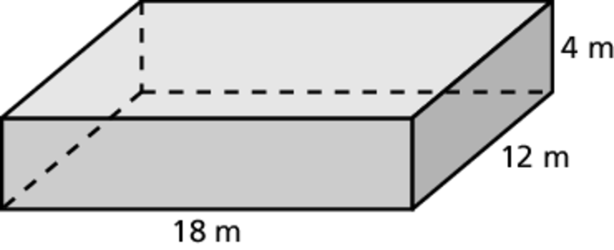
3. 4.
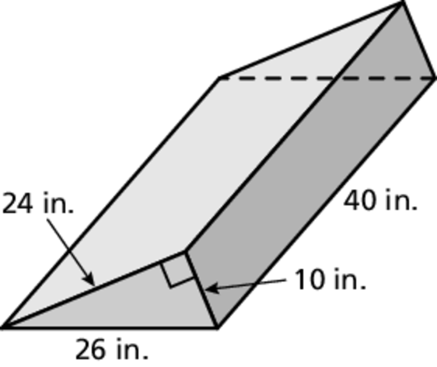
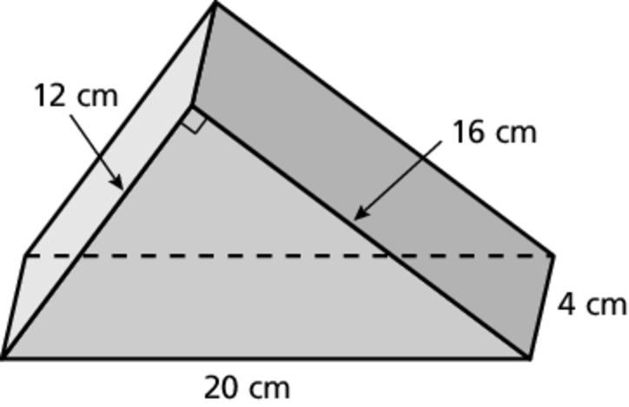
5. 6.
7. The inside of a baking pan is to be lined with tinfoil. The pan is 12 inches long,
9 inches wide, and 1.5 inches tall. How many square inches of tinfoil are needed?
8. Draw and label a rectangular prism that has a surface area of 96 square meters.
Name Date
Practice B
9.1
Find the surface area of the prism.
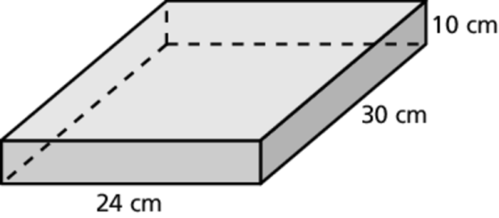
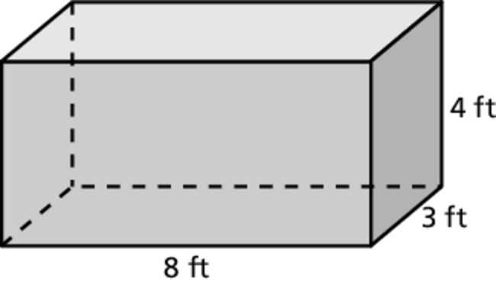
1. 2.
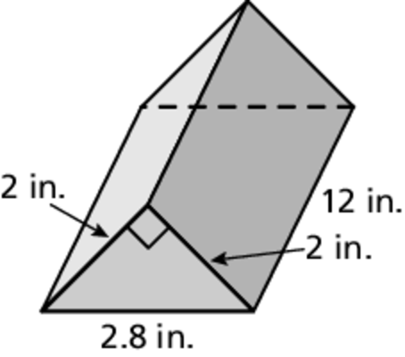
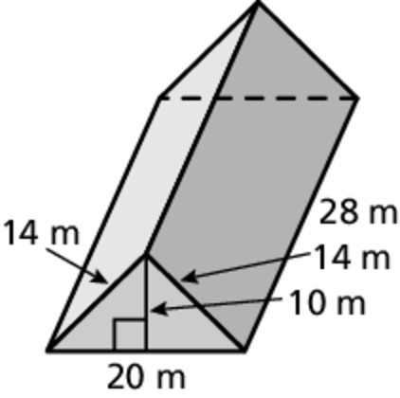
3. 4.
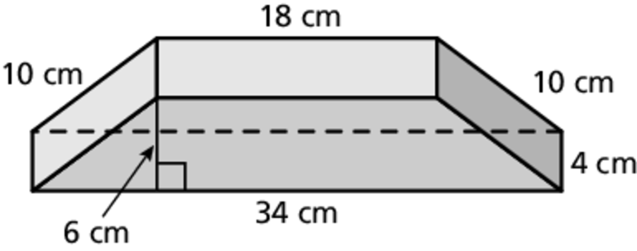
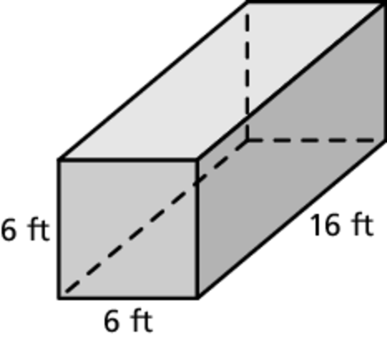
5. 6.
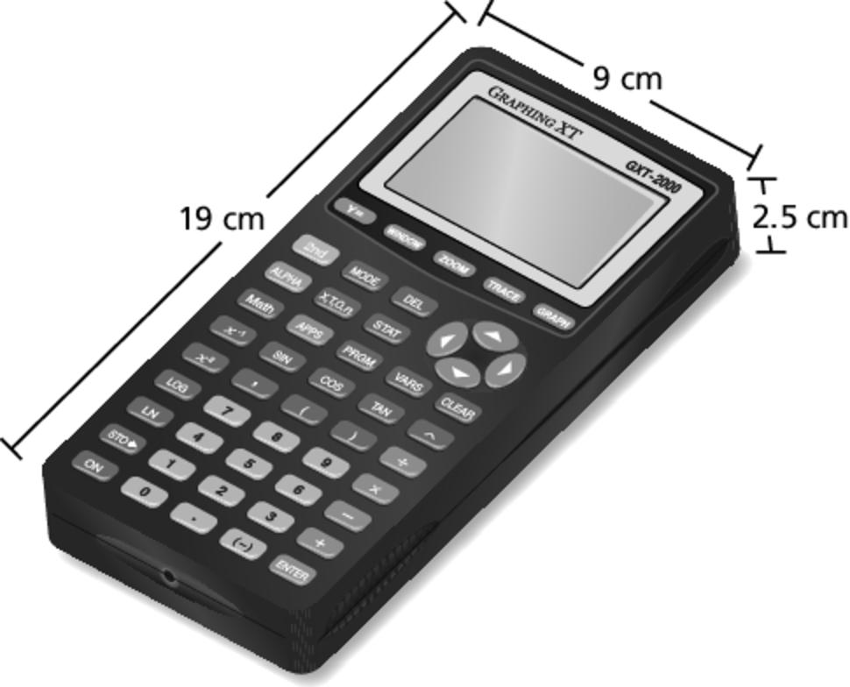
7. A graphing calculator is in the approximate
shape of a rectangular prism.
a. Estimate the total surface area
of the calculator.
b. The window of the calculator
is 6.5 centimeters long
and 4.5 centimeters wide.
Estimate the surface of
the graphing calculator
without the window.
8. The least amount of wrapping paper needed to wrap a cube-shaped gift is 150 square inches. How long is one side of the gift?

