Name Date
Enrichment and Extension
9.1
Boxing Up Basketballs and Cereal
Olivia works in the design department of a packaging company. Help her by answering the following questions.
1. Olivia has to design a plastic shipping container that will hold 12 basketballs
in individual boxes. The basketballs have a radius of 4.5 inches and fit exactly
in their individual boxes that are cubes.
a. Give the dimensions (in inches) of 4 different plastic shipping containers
that would fit the boxes exactly. Two containers with the same dimensions
in a different order do not count as different containers. Find the surface
area of each of your designs.
b. Divide each surface area from part (a) by 144 to convert it to square feet. Explain why you divide by 144.
c. Olivia's company made 100 containers one month with the design that uses the most plastic. The next month, they made 100 containers with the design that uses the least plastic. How much plastic (in square feet) did the company save in the second month?
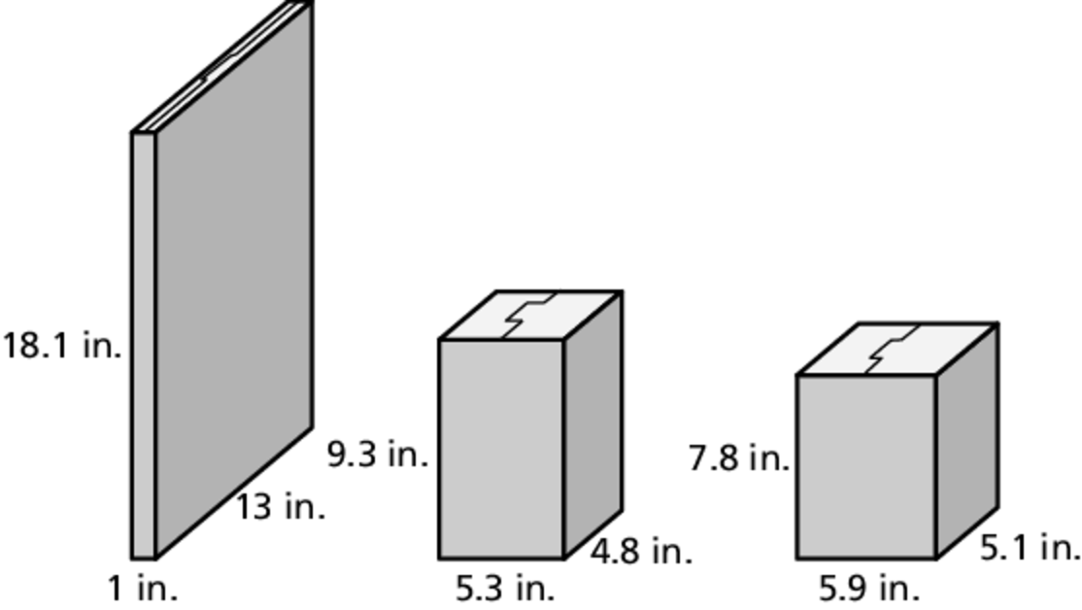
2. Next, Olivia was asked to consider
some new designs for a cereal box
that was originally 7.7 inches by
2.6 inches by 11.8 inches. Each of
the new designs will hold roughly
the same amount of cereal as the
original.
a. Find how much cardboard
(in square inches) it would
take to make the original
cereal box as well as each
of the new designs.
b. Olivia’s company made 1000 cereal boxes with the design that uses the least cardboard. How many square feet of cardboard would they save compared to making 1000 of the original boxes?
c. What are some advantages to the design with the least surface area? disadvantages? What design do you think Olivia should recommend? Explain your reasoning.
3. Look for a pattern in Exercises 1 and 2. Predict what kind of rectangular prism has the least surface area.

