Name Date

puzzle

Puzzle Time

8.4

What Did One Flea Say To Another Flea?

10.6

|  |  |  |  |  |  |
| --- | --- | --- | --- | --- | --- |
| A | B | C | D | E | F |
| G | H |  | | | |

Complete each exercise. Find the a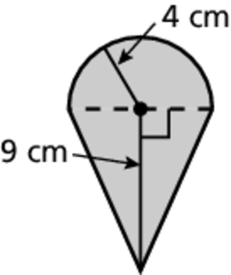n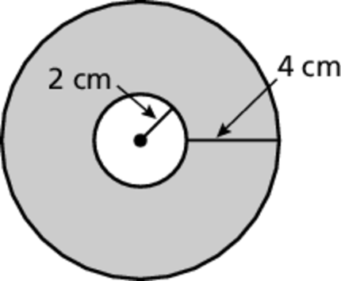swer in th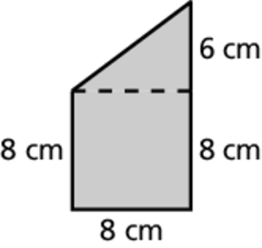e 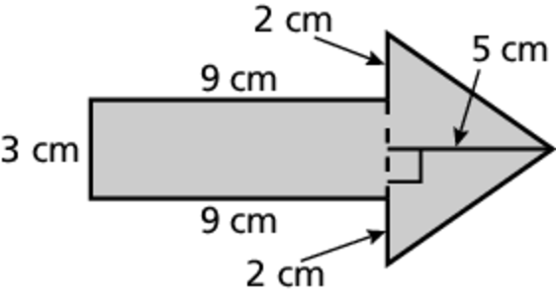a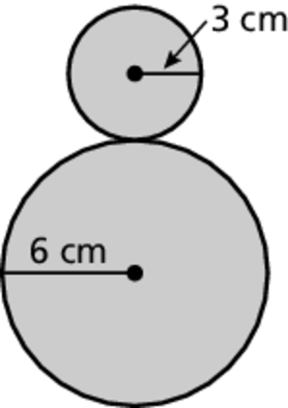nswer column. Write the word under the answer in th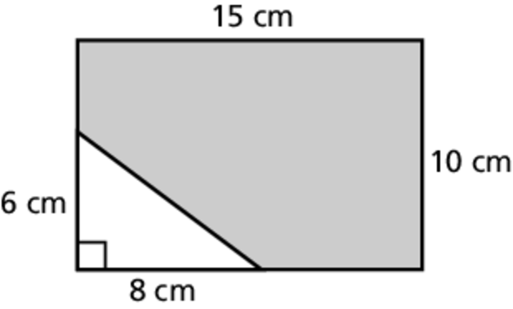e box 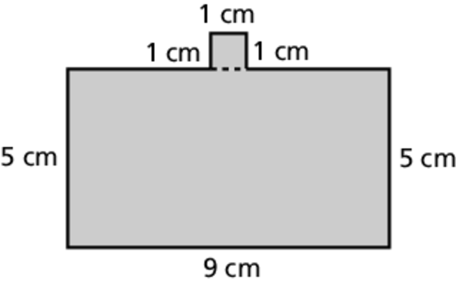containing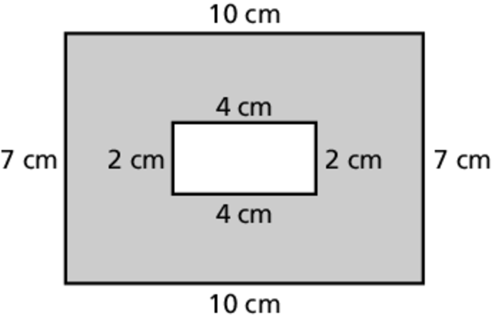 the exercise letter.

Find the area of the shaded region of the figure.

A. B.

C. D.

E. F.

G. H.

|  |
| --- |
| 61.12 cm2  HOP |
| 126 cm2  A |
| 46 cm2  DO |
| 100.48 cm2  DOG |

|  |
| --- |
| 44.5 cm2  WALK |
| 141.3 cm2  OR |
| 88 cm2  WE |
| 62 cm2  ON |