Name Date

8.3

puzzle

Puzzle Time

What Do Little Piggies Do As Soon As They Get Home From School?

Write the letter of each answer in the box containing the exercise number.

Find the area of the circle. Use 3.14 or for 

Answers

K. 

H. 

M. 

R. 

W. 

O. 

A. 

1. 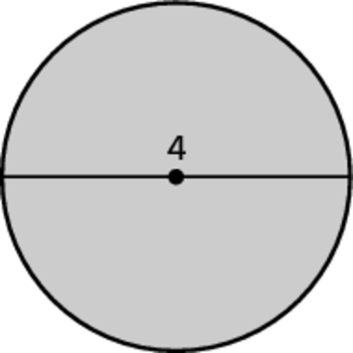 2. 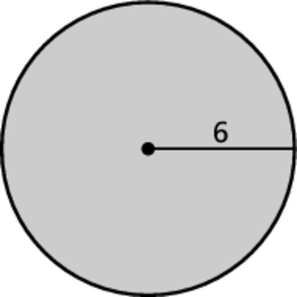

3. 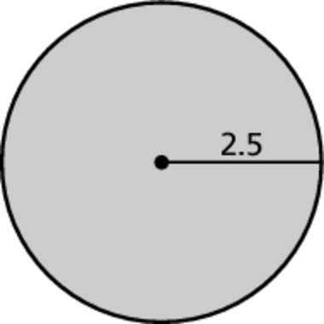 4. 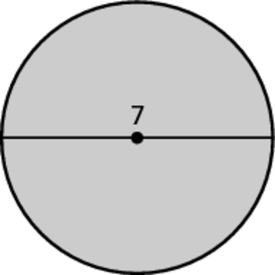

5. 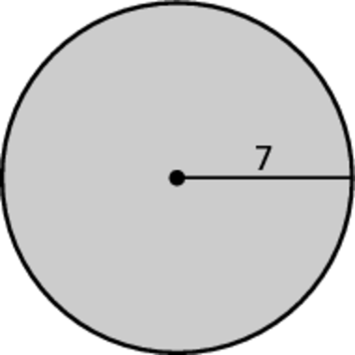

Find the area of the semicircle. Use 3.14 for 

6. 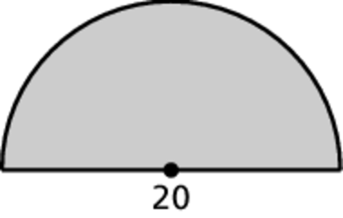 7. 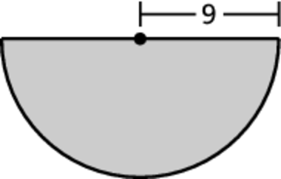

|  |  |  |  |  |  |  |
| --- | --- | --- | --- | --- | --- | --- |
| 1 | 6 | 3 | 5 | 2 | 7 | 4 |
|  |  |  |  |  |  |  |