Name Date

Practice A

8.3

Find the area of the circle. Use 3.14 or 

1. 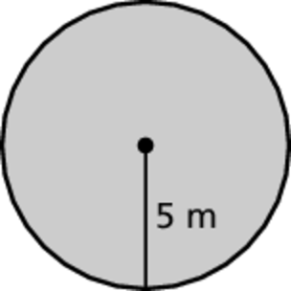 2. 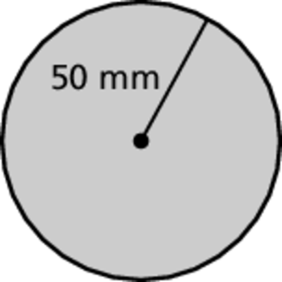 3. 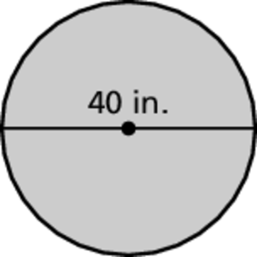

4. 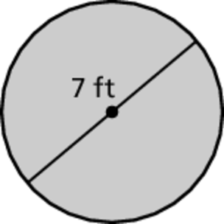 5. 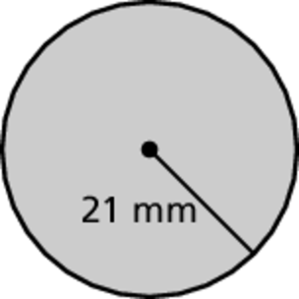 6. 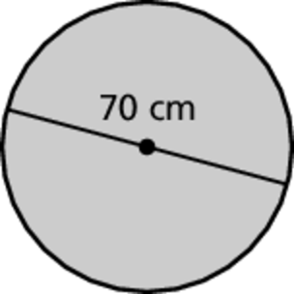

Find the area of the object.

7. 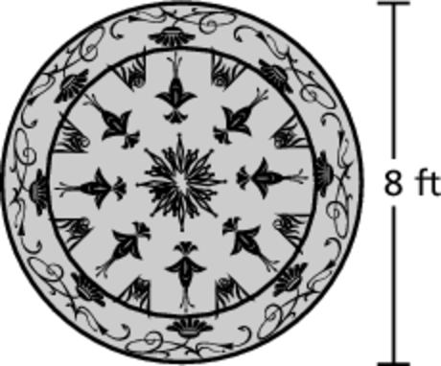 8. 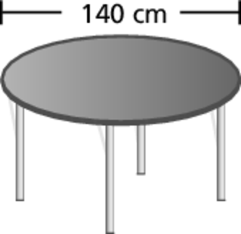 9. 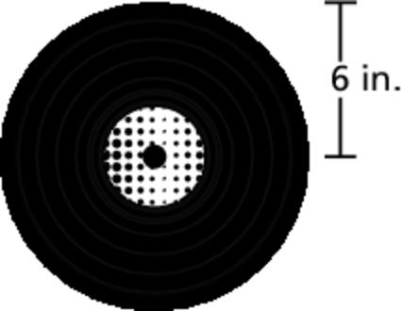

10. You use the compass to draw 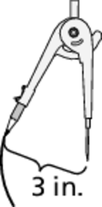  
a circle. What will be the area   
of the circle?

11. What fraction of a square inch is the area of one 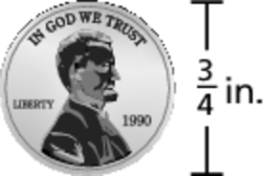  
side of a penny? Use  forWrite your answer   
in simplest form.

12. To make a pizza, you spread pizza sauce over 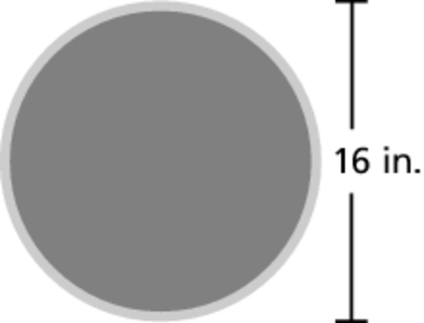  
all but a 1-inch area around the outside edge   
as shown. What area of the crust is covered   
with sauce?

Name Date

Practice B

8.3

Find the area of the circle. Use 3.14 or 

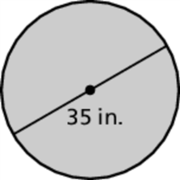 1. 2. 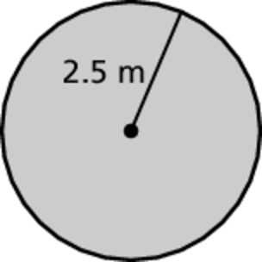 3. 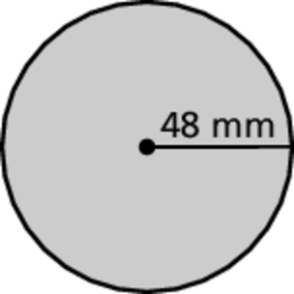

Find the area of the semicircle.

4. 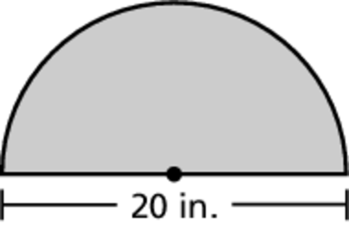 5. 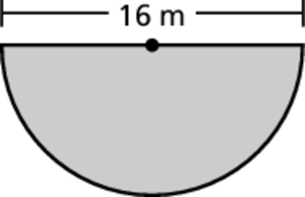 6. 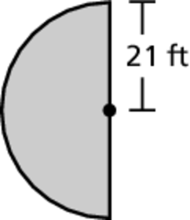

7. The shadow of an object is roughly the same 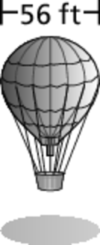size as the object. What is the area of the circular shadow of the hot air balloon?

8. How many *square feet* of 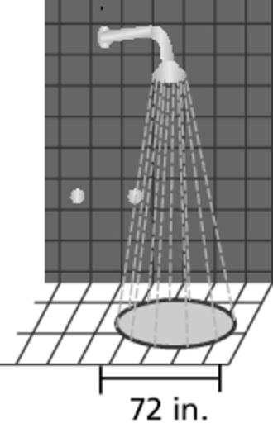  
the ground are sprayed by   
the beach shower?

9. The radius of the small circle is half the radius of the large circle.

a. Use the radius *r* to write a formula for the area of the large circle. 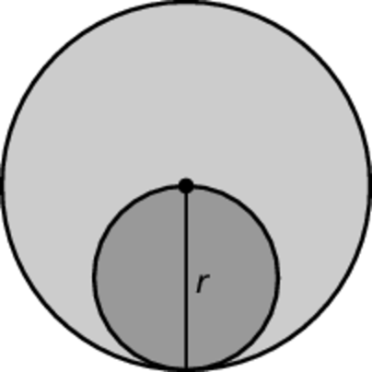

b. Use the radius  to write a formula for the area of the   
small circle.

c. How does the area of a circle compare to the area of another   
circle whose radius is twice as large? Explain your reasoning.

10. The number of square inches of a circle’s area is equal to the number of inches of its circumference. What is the radius of the circle? Explain how you found your answer.