Name Date
Enrichment and Extension
8.3
Where Are You Located?
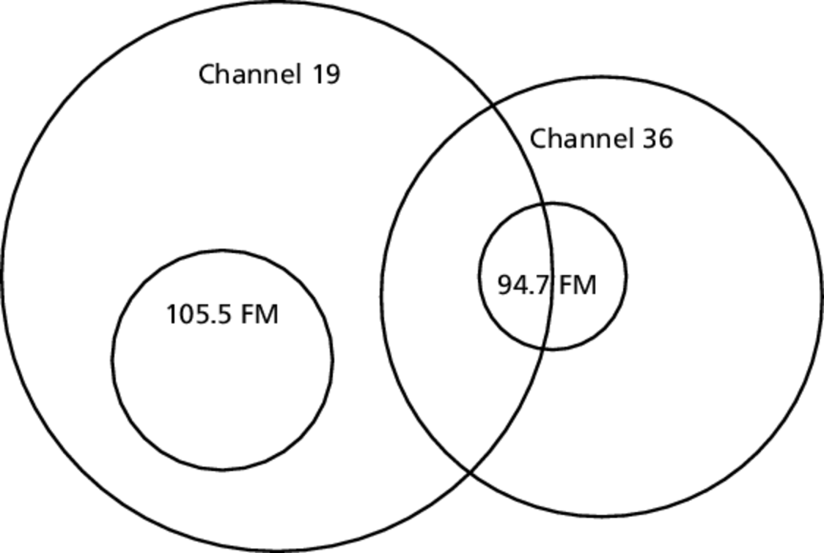
The circular broadcast areas of two television stations and two radio stations are shown in the diagram. Use 3.14 for
 | Broadcast radius (mi)
TV Channel 19 | 150
TV Channel 36 | 120
Radio 105.5 FM | 60
Radio 94.7 FM | 40

1. How many times larger is the broadcasting area of Channel 19 than the broadcasting area of Channel 36?
2. How many times larger is the broadcasting area of 105.5 FM than the broadcasting area of 94.7 FM?
3. What percent of the broadcast area of Channel 19 is also in the broadcast area of 105.5 FM?
4. What fraction of the broadcast area of Channel 36 is also in the broadcast area of 94.7 FM?
5. Half of the broadcast area of 94.7 FM can watch both television channels.
a. What percent of the broadcast area of Channel 19 can listen to 94.7 FM?
b. You can watch one of the television channels and can listen to one of the radio stations. Draw a diagram and shade the area where you may be located. What is the total area of the shaded region?
c. Your friend can watch Channel 19 but cannot listen to either of the radio stations. You do not know if your friend can watch Channel 36. Draw a diagram and shade the area where your friend may be located. What is the total area of the shaded region?

