Name Date

8.2

puzzle

Puzzle Time

What Is The Building In Your City That Has The Most Stories?

Answers

R. 22.56

B. 40

I. 30.28

Y. 33.42

R. 82.24

L. 22

A. 74.82

Write the letter of each answer in the box containing the exercise number.

Find the perimeter of the figure.

1. 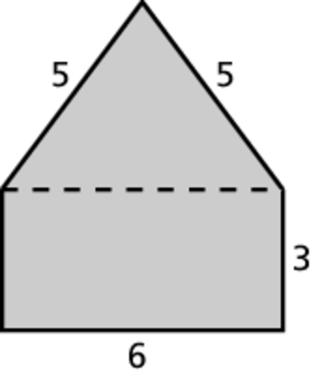 2. 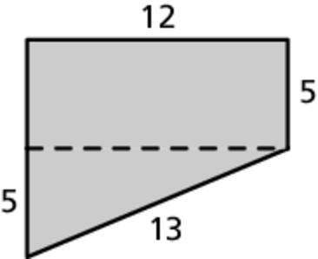

3. 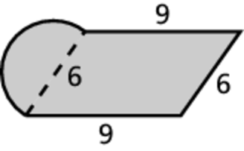 4. 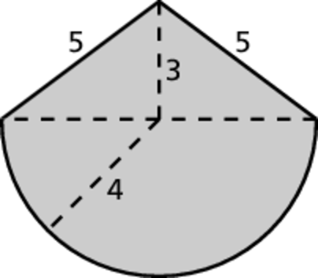

5. 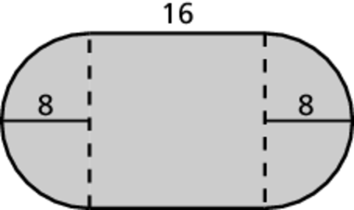 6. 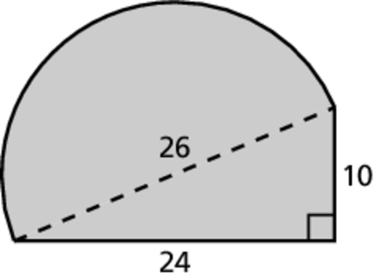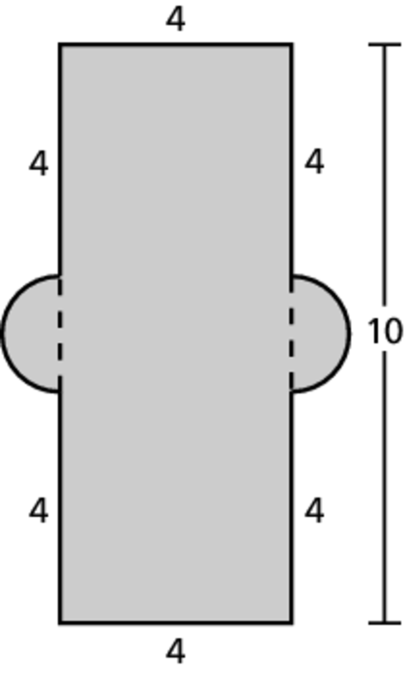 7.

|  |  |  |  |  |  |  |
| --- | --- | --- | --- | --- | --- | --- |
| 1 | 6 | 2 | 5 | 7 | 4 | 3 |
|  |  |  |  |  |  |  |