Name Date

Practice A

8.2

Estimate the perimeter of the figure.

1. 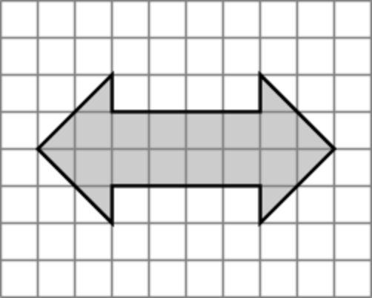 2. 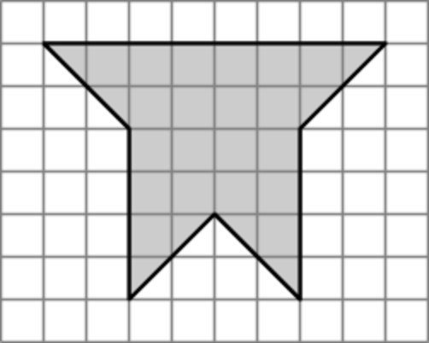 3. 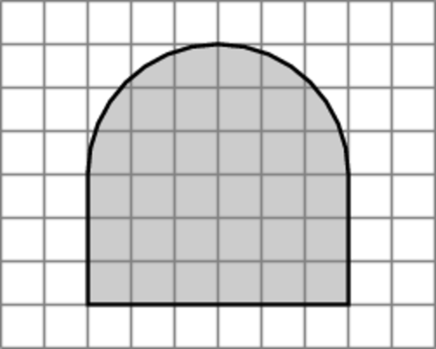

Find the perimeter of the figure.

4. 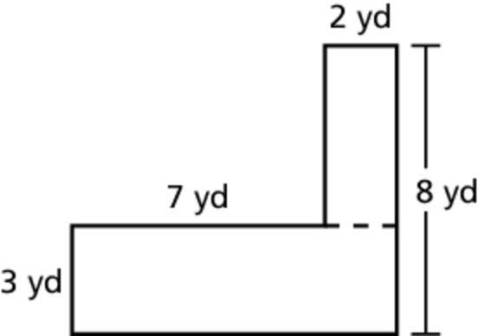 5. 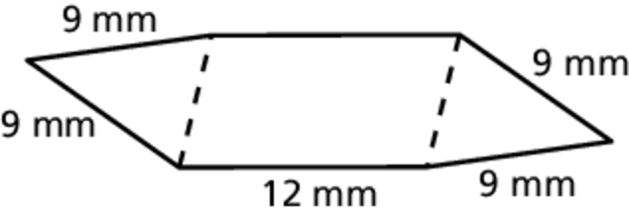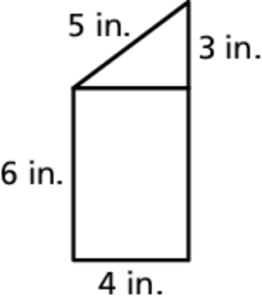 6.

7. 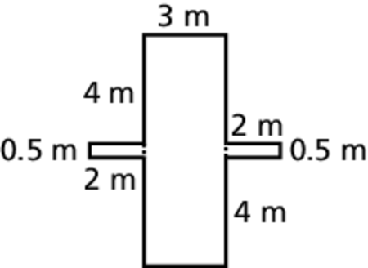 8. 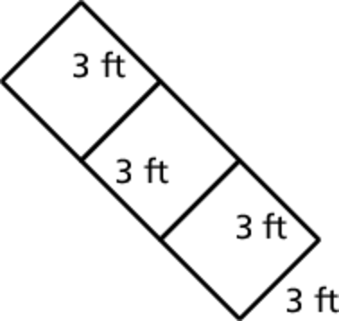 9. 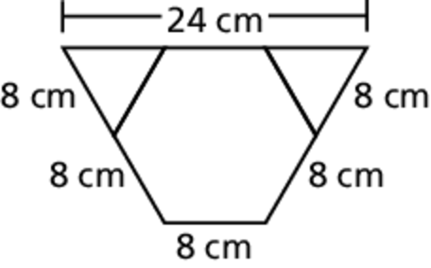

10. A stained glass window has the dimensions 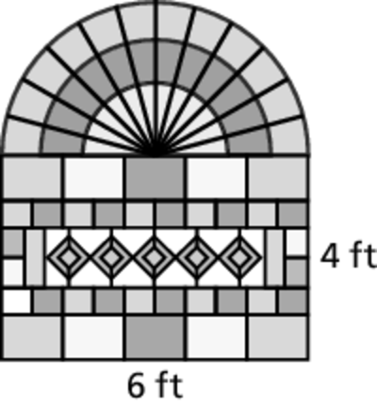  
shown. What is the perimeter of the hole   
that should be cut in the wall in order for   
the window to be installed?

11. The dimensions of a new city park   
basketball court are shown at the 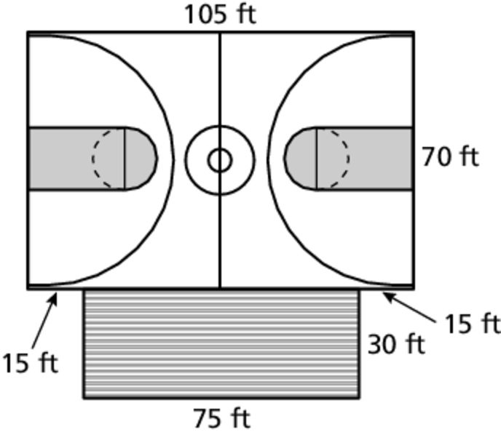  
right. A fence is to be built around   
the court and bleachers. The fence   
costs $8.99 per foot. How much will   
it cost to install the fence?

Name Date

Practice B

8.2

Estimate the perimeter of the figure.

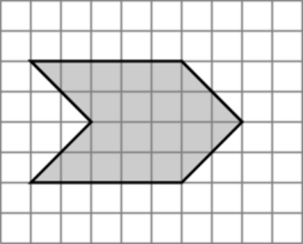 1. 2. 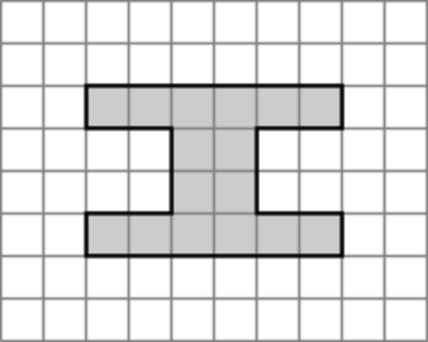 3. 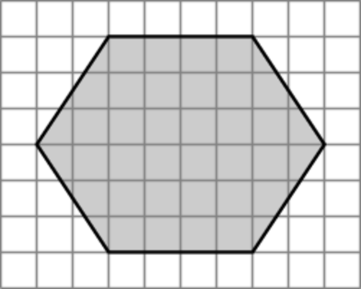

Find the perimeter of the figure.

4. 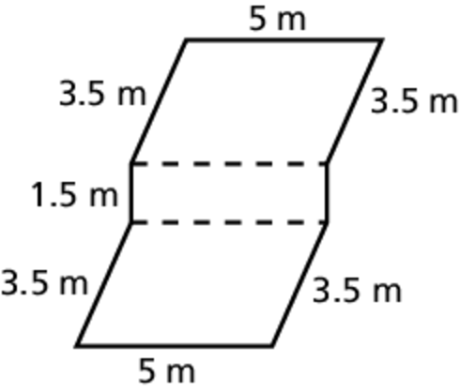 5. 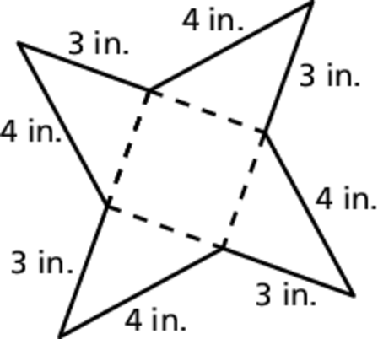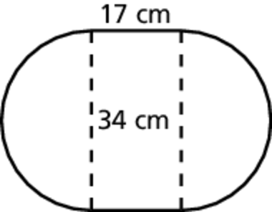 6.

7. 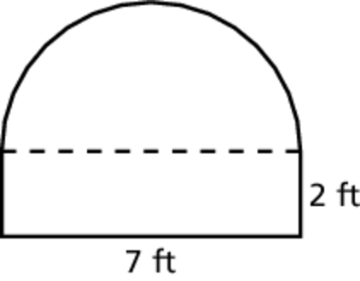Describe and correct the error in finding the perimeter of the figure.



8. A school has a garden in the shape 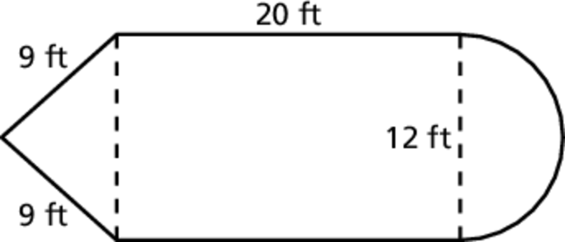  
of a pencil. A fence is to be built   
around the garden. The fence costs   
$2.75 per foot. How much will it   
cost to install the fence?

9. A shrub has been cut and trimmed into the shape of an “F.” The owner has hired a landscaper to decrease the 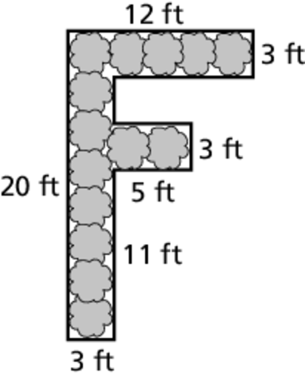perimeter of the shrub by 10 feet. Draw a diagram of how the landscaper might do this. Is there more than one way? Explain.