Name Date

puzzle

Puzzle Time

8.1

Why Was The Gentleman Who Was Selling Watches Unhappy?

10.6

|  |  |  |  |  |  |
| --- | --- | --- | --- | --- | --- |
| A | B | C | D | E | F |
| G | H |  | | | |

Complete each exercise. Find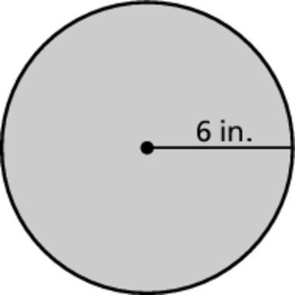 the answer in the answer column. Write the word under the 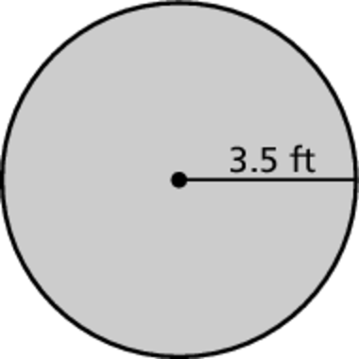answ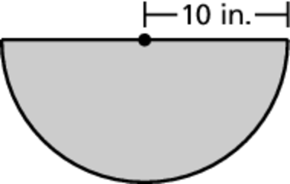er 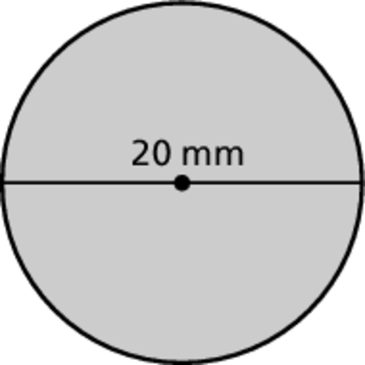in the 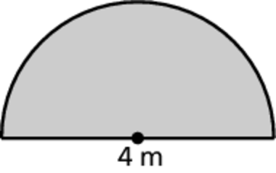b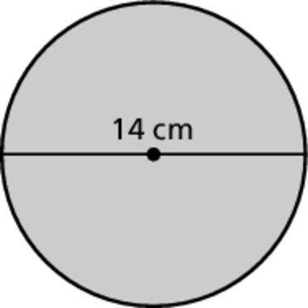ox containing the exercise letter.

A. The diameter of a circle is 30 meters. Find the radius.

B. The radius of a circle is 11 millimeters. Find the diameter.

Find the circumference of the circle. Use 3.14 or   
for 

C. D.

E. F.

Find the perimeter of the semicircle. Use 3.14 for 

G. H.

|  |
| --- |
| 62.8 mm  MUCH |
| 15 m  HE |
| 44 cm  TIME |
| 37.68 in.  TOO |

|  |
| --- |
| 51.4 in.  HANDS |
| 22 ft  ON |
| 10.28 m  HIS |
| 22 mm  HAD |