Name Date

Practice A

8.1

Find the diameter of the circle.

1. 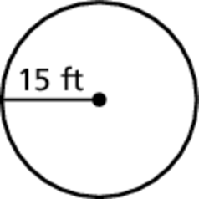 2. 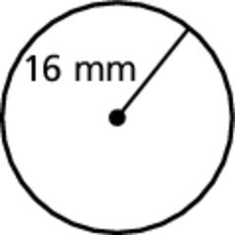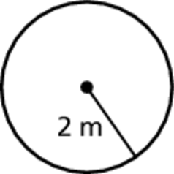 3.

Find the radius of the circle.

4. 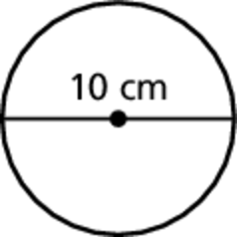 5. 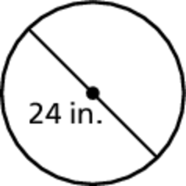 6. 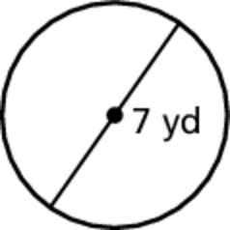

Find the circumference of the circle. Use 3.14 or  for

7. 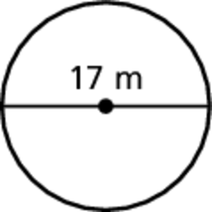 8. 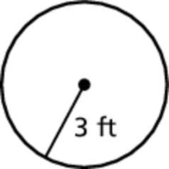 9. 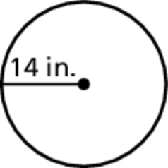

Find the perimeter of the semicircular region.

10. 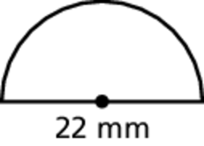 11. 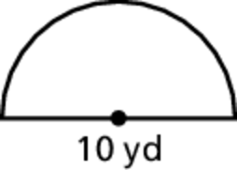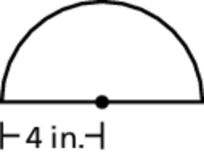 12.

13. A circular ink spot has a circumference of 25.12 millimeters. A minute later, it has a circumference of 75.63 millimeters.

a. Estimate the diameter of the ink spot each minute.

b. How many times greater is the diameter of the ink spot compared to the previous minute?

14. You are enclosing a circular flower garden with a fence that costs $2.99 per foot. The radius of the garden is 7 feet. How much will it cost to buy the fence? 

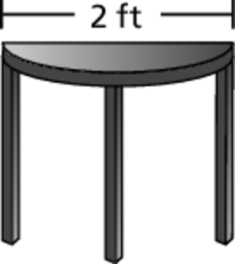 15. Find the perimeter of the semicircular   
tabletop shown at the right.

Name Date

Practice B

8.1

Find the circumference of the circle. Use 3.14 or  for 

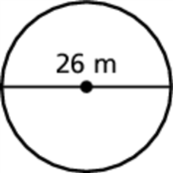 1. 2. 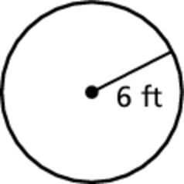 3. 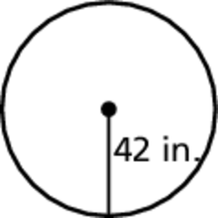

Find the perimeter of the semicircular region.

4. 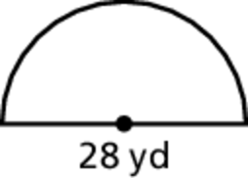 5. 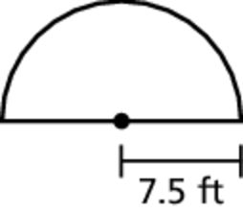 6. 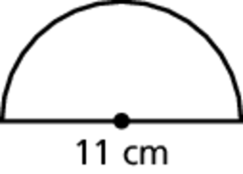

7. Copy and complete the table for Circles A, B, C, and D.

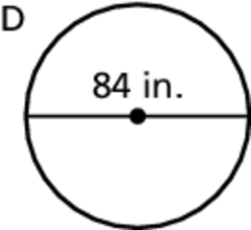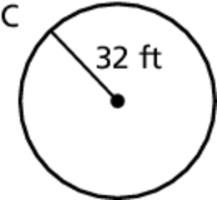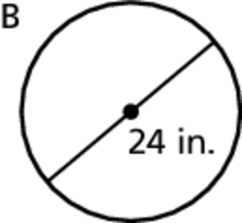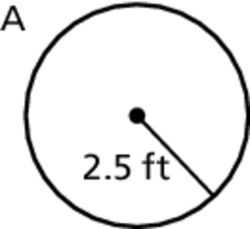

|  |  |  |  |  |
| --- | --- | --- | --- | --- |
| Circle | A | B | C | D |
| Radius | 2.5 ft | ? ft | 32 ft | ? ft |
| Diameter | ? in. | 24 in. | ? in. | 84 in. |

8. A coaster has a circumference of 12.56 inches. Suppose the 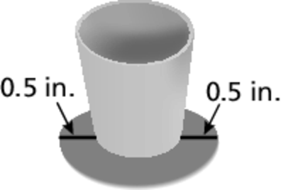  
same amount of coaster is visible around the bottom of a   
glass as shown. What is the circumference of the glass?

9. Are the side lengths of the squares in 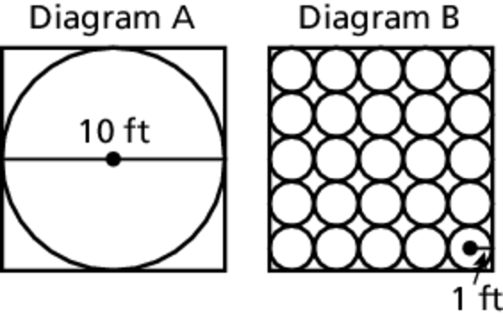  
Diagram A and Diagram B equivalent? Explain your reasoning?

10. You release a ball with a radius of 1 inch into   
a pipe as shown. How many times will the 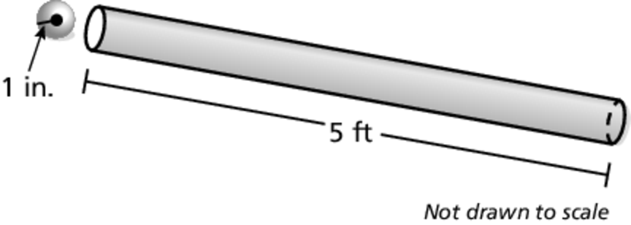  
ball rotate before it falls out of the other end   
of the pipe?