Name Date

Enrichment and Extension

8.1

Changing Dimensions

Find the circumference of the circle. Then find the circumference if the radius is multiplied by 2. Use 3.14 for**

1. 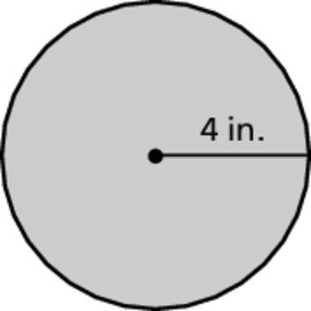 2. 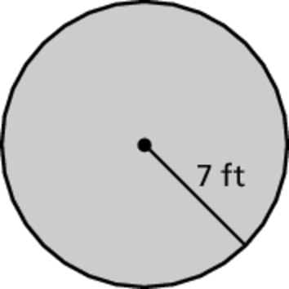 3. 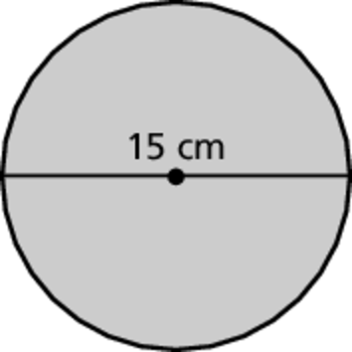

4. What happens to the circumference of a circle when its radius is multiplied by 2?

5. What happens to the circumference of a circle when its radius is multiplied by a positive number *n*?

Find the perimeter of the semicircle. Then find the perimeter if the radius is multiplied by  Use 3.14 for**

6. 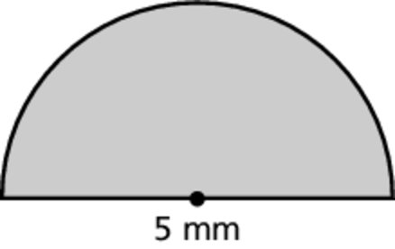 7. 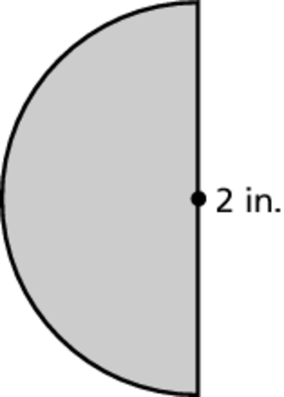 8. 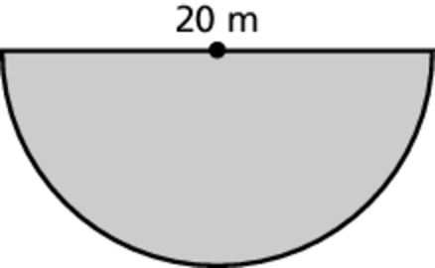

9. What happens to the perimeter of a semicircle when its diameter is multiplied by ?

10. What happens to the perimeter of a semicircle when its radius is multiplied by a positive number *n*?