Name Date

Practice A

7.5

1. Use the drawing of the game court and an inch ruler. Each inch in the drawing represents 8 feet.

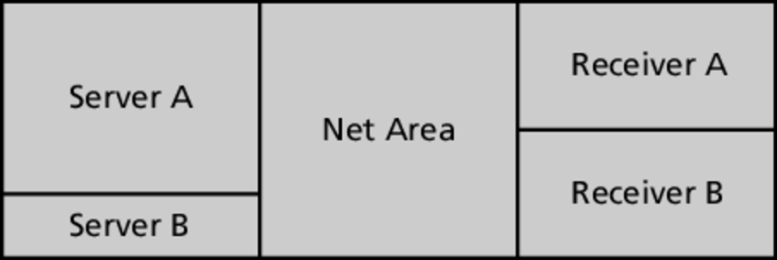

a. What is the actual length of the court?

b. What are the actual dimensions of Receiver A?

c. What are the actual dimensions of the Net Area?

d. The area of Server B is what percent of the area of Server A?

e. What is the ratio of the perimeter of Receiver B to the perimeter of   
Net Area?

f. What is the ratio of the area of Receiver B to the area of Net Area?

g. Are Receiver B and Net Area similar rectangles?

h. The area of Server A is increased by what percent to get the area of   
Net Area?

Find the missing dimension. Use the scale factor 1 : 5.

2. Model: 3 ft 3. Model: 7 m

Actual:  Actual: 

4. Model:  5. Model: 

Actual: 20 yd Actual: 12.5 cm

6. A scale drawing of a rose is 3 inches long. The actual rose is 1.5 feet long.

a. What is the scale of the drawing?

b. What is the scale factor of the drawing?

Name Date

Practice B

7.5

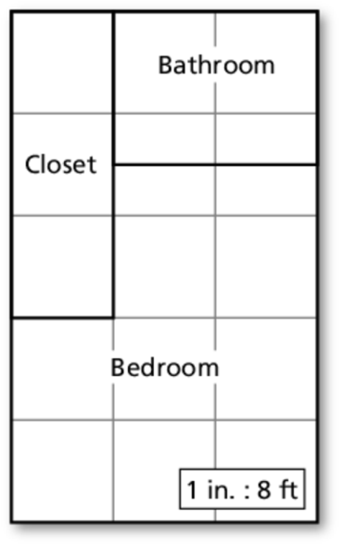 1. In the actual blueprint of the bedroom suite, each

square has a side length of  inch.

a. What are the dimensions of the bedroom suite?

b. What are the dimensions of the bathroom?

c. What is the length of the longest wall in   
the bedroom?

d. What is the ratio of the perimeter of the closet   
to the perimeter of the bathroom?

e. What is the ratio of the area of the closet to the   
area of the bathroom? How can you explain this   
by looking at the squares in each?

f. All of the walls in the bedroom suite are covered with drywall. Which will cost the most to drywall—*the* *closet*, *the* *bathroom*, or *both are   
the same*?

g. All of the floors in the bedroom suite are covered with tile. Which will cost the most to tile—*the* *closet*, *the* *bathroom*, or *both are the same*?

h. What is the area of the bedroom?

Find the missing dimension. Use the scale factor 2 : 5.

2. Model: 10 km 3. Model: 5 in.

Actual:  Actual: 

4. Model:  5. Model: 

Actual: 24 ft Actual: 32.5 m

6. A scale factor is 1 : 8. Describe and correct the error in finding the model length that corresponds to 48 feet.

