Name Date

7.4

puzzle

Puzzle Time

What’s The Healthiest Insect?

Answers

N. rectangle

A. kite

E. rhombus

M. trapezoid

I. square

T. parallelogram

E. 90

B. 65

V. 38

I. 55

Write the letter of each answer in the box containing the exercise number.

Classify the quadrilateral.

1. 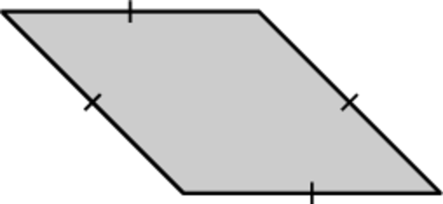 2. 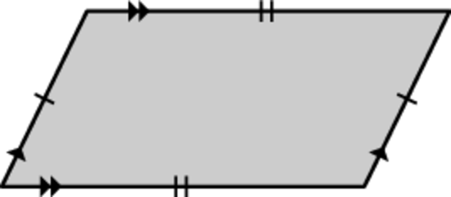

3. 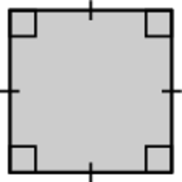 4. 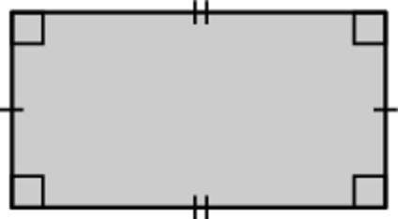

5. 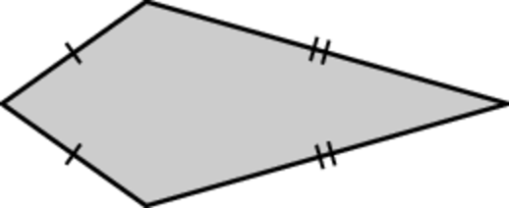 6. 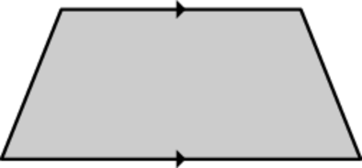

Find the value of *x*.

7. 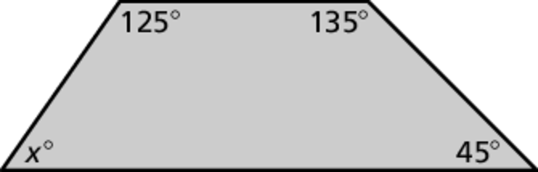

8. 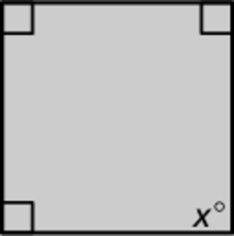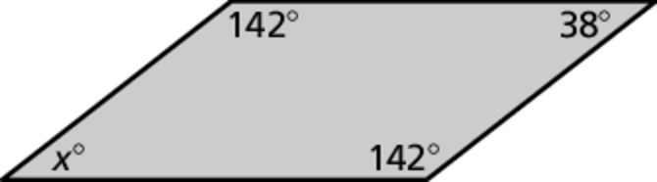 9.

10. 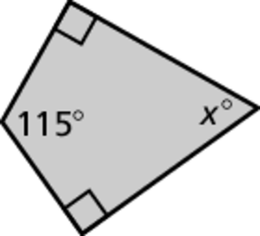

|  |  |  |  |  |  |  |  |  |  |  |
| --- | --- | --- | --- | --- | --- | --- | --- | --- | --- | --- |
| 9 | 7 | 2 | 5 | 6 | 3 | 4 |  | 10 | 1 | 8 |
|  |  |  |  |  |  |  |  |  |  |  |