Name Date

Practice A

7.4

Classify the quadrilateral.

1. 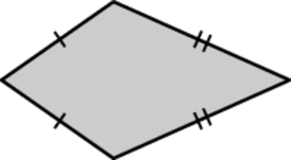 2. 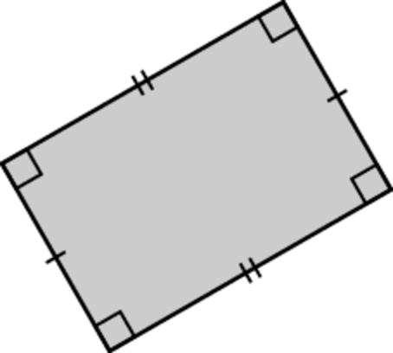

3. 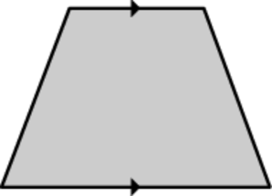 4. 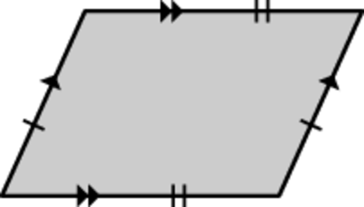

Find the value of *x*.

5. 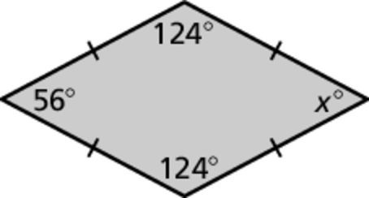 6. 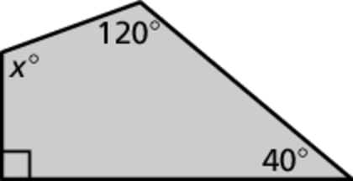

**Copy and complete using *always*, *sometimes*, or *never*.**

7. A square is  a rhombus.

8. A parallelogram is  a rectangle.

9. A kite is  a square.

10. A trapezoid is  a square.

11. Draw the following trapezoids. If it is not possible, explain why.

a. a trapezoid with one right angle

b. a trapezoid with two right angles

c. a trapezoid with three right angles

d. a trapezoid with four right angles

Name Date

Practice B

8.1

Practice B

7.4

Classify the quadrilateral.

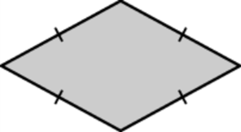 1. 2. 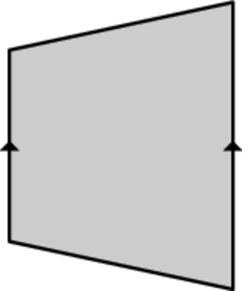

Find the value of *x*.

3. 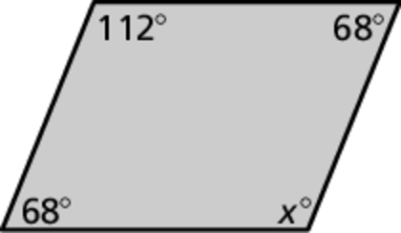 4. 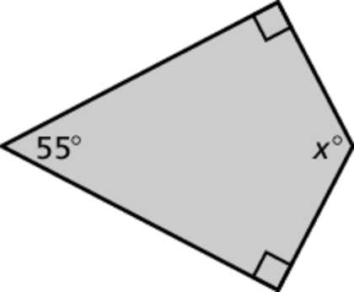

**Copy and complete using *always*, *sometimes*, or *never*.**

5. A rectangle is  a square.

6. A rhombus is  a parallelogram.

7. A trapezoid is  a kite.

8. A parallelogram is  a rhombus.

9. Determine whether the statement is *true* or *false*. Explain your reasoning. You may use diagrams to explain your reasoning.

a. A rectangle that is 30 inches long and 10 inches wide can be divided into two congruent squares.

b. A rectangle that is 30 inches long and 10 inches wide can be divided into three congruent squares.

c. A parallelogram with opposite congruent sides of 6 feet and 3 feet can be divided into two congruent rhombuses.

d. A rectangle that is 30 inches long and 10 inches wide can be divided into two congruent trapezoids.

e. A rhombus that has side length 8 meters can be divided into two congruent parallelograms.