Name Date

puzzle

Puzzle Time

7.3

Why Did The Kindergartener Take Her Books To The Zoo?

10.6

|  |  |  |  |  |  |
| --- | --- | --- | --- | --- | --- |
| A | B | C | D | E | F |
| G | H | I |  | | |

Complete each exe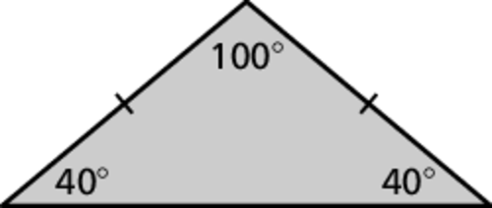rcise. Find the answer in the answer column. Write the word under the a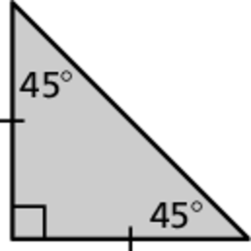nswe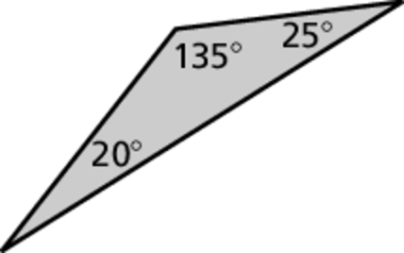r 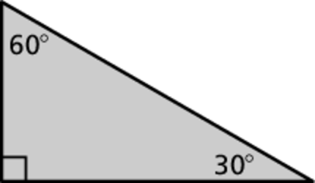in 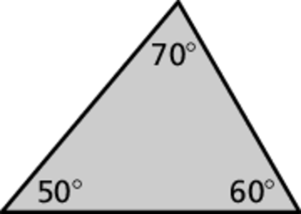the 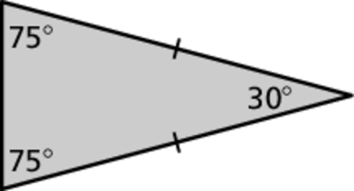box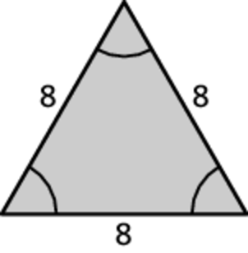 containing the exercise letter.

Classify the triangle.

A. B.

C. D.

E. F.

G.

H. A triangle contains angles measuring    
How many degrees is the third angle of the triangle?

I. A triangle contains angles measuring  and.   
How many degrees is the third angle of the triangle?

|  |
| --- |
| Equilateral and Equiangular Triangle  TO |
| 80  LIONS |
| Acute Scalene Triangle  READ |
| Obtuse Scalene Triangle  WANTED |
| Right Isosceles Triangle  BETWEEN |

|  |
| --- |
| Obtuse Isosceles Triangle  TO |
| Acute Isosceles Triangle  SHE |
| Right Scalene Triangle  LEARN |
| 115  THE |