Name Date

Practice A

7.3

Classify the triangle.

1. 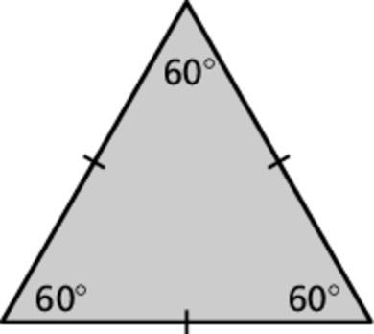 2. 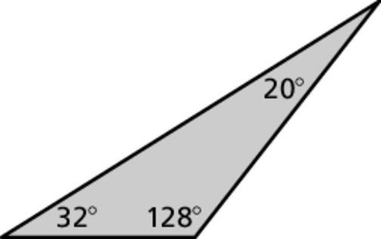

3. 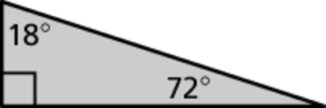 4. 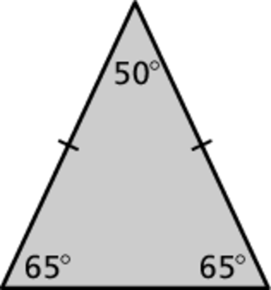

Draw a triangle with the given description.

5. a right triangle with two congruent sides

6. a scalene triangle with a 3-inch side and a 4-inch side that meet at   
a angle

7. Consider the three isosceles right triangles.

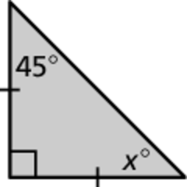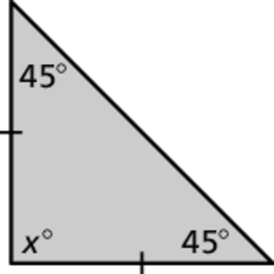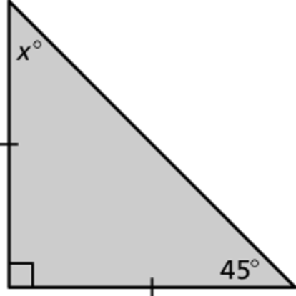

a. Find the value of *x* for each triangle.

b. What do you notice about the angle measures of each triangle?

c. Write a rule about the angle measures of an isosceles right triangle.

Name Date

Practice B

7.3

Classify the triangle.

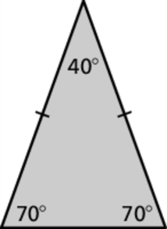 1. 2. 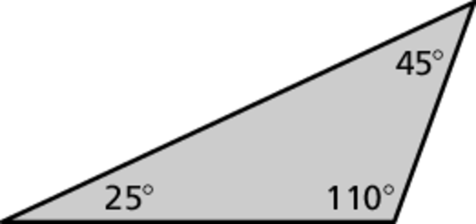

Draw a triangle with the given angle measures. Then classify the triangle.

3.  4. 

**Draw a triangle with the given description.**

5. an obtuse scalene triangle

6. a triangle with a angle connected to a angle by a 6-inch side

Determine whether you can construct *many*, *one*, or *no* triangle(s) with   
the given description. Explain your reasoning.

7. a triangle with a 2-inch side, a 4-inch side, and a 5-inch side

8. a scalene triangle with two 7-centimeter sides

9. a triangle with one angle measure of  and one 6-inch side

10. Draw a circle. Draw a triangle with the given description such that all   
three vertices of the triangle touch the circle.

a. Draw an obtuse triangle.

b. Draw a right triangle.

c. Draw an acute triangle.