Name Date

Enrichment and Extension

7.3

Writing Ratios

The sides of a right triangle can be named by their locations 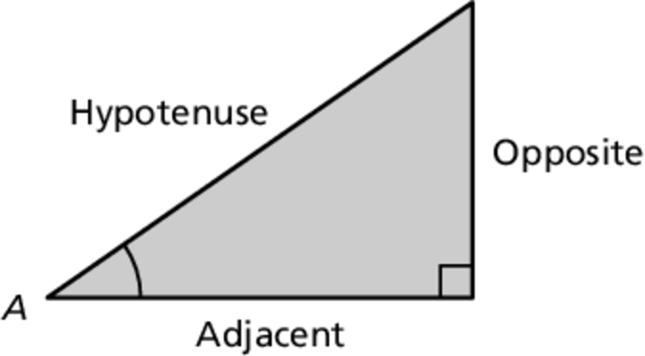  
with respect to an angle of the triangle.

Trigonometry

It is possible to write ratios that compare the lengths of   
the sides in the triangle using special functions and a   
given angle. These ratios are called sine (sin), cosine (cos),   
and tangent (tan) and are studied in depth in a branch of   
mathematics called trigonometry.

  

**Write the ratios. Use your answers and the color key to shade the mosaic.**

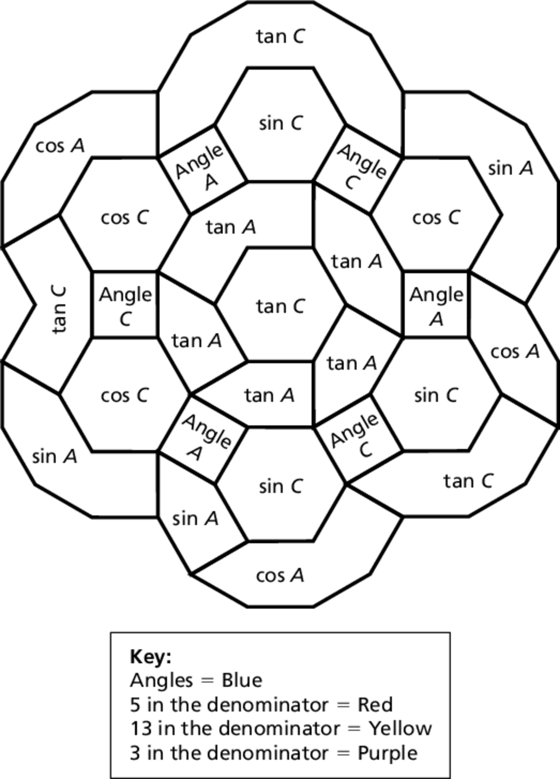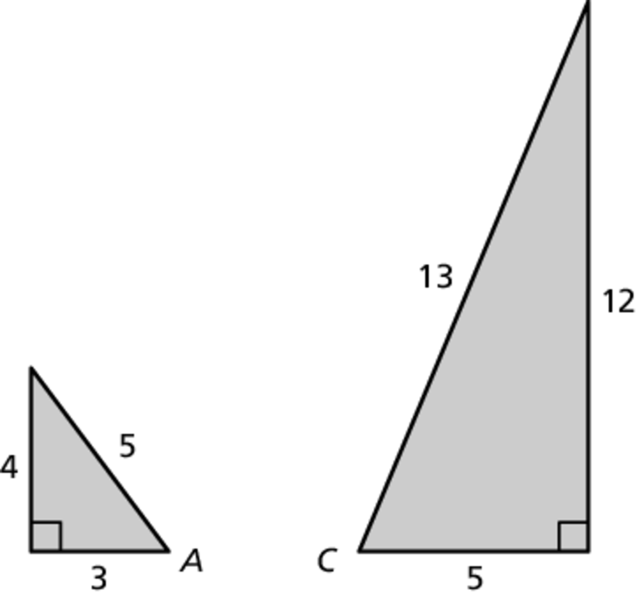

1. sin *A* 2. tan *C*

3. cos *A* 4. tan *A*

5. sin *C* 6. cos *C*