Name Date

7.2

puzzle

Puzzle Time

What Is The Best Year For Grasshoppers?

10.6

Write the letter of each answer in the box containing the exercise number.

Answers

Y. 10

P. 20

A. neither

E. 4

A. 15

E. complementary

R. supplementary

L. 27

Tell whether the angles are *complementary*, *supplementary*,   
or *neither*.

1. 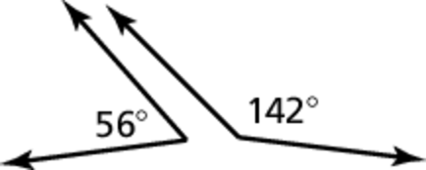 2. 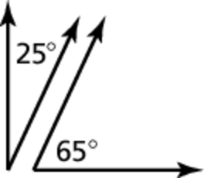

3. 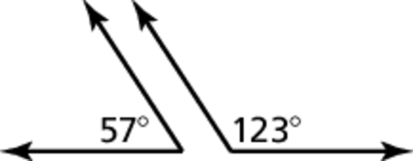

Find the value of *x*.

4. 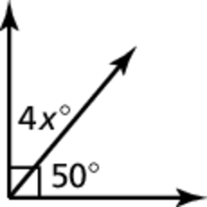 5. 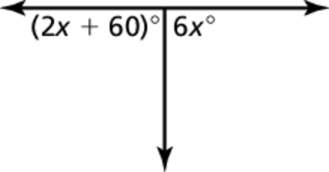

6. 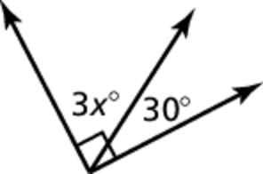 7. 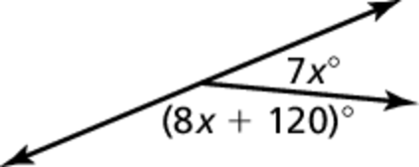

8. The crosswalk in front of a school intersects the sidewalk at   
an angle of  Find the value of *x*. 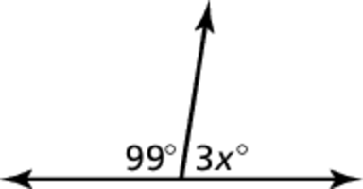

|  |  |  |  |  |  |  |  |  |
| --- | --- | --- | --- | --- | --- | --- | --- | --- |
| 8 | 7 | 1 | 6 |  | 4 | 2 | 5 | 3 |
|  |  |  |  |  |  |  |  |  |