Name Date

Practice A

7.2

Tell whether the statement is *always*, *sometimes*, or *never* true. Explain.

1. If *x* and *y* are supplementary angles, then *y* is acute.

2. If *x* and *y* are complementary angles, then *x* is obtuse.

Tell whether the angles are *complementary*, *supplementary*, or *neither*.

3. 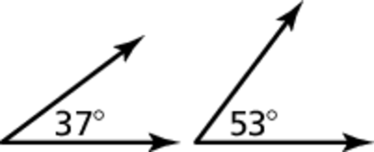 4. 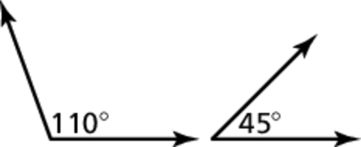

5. 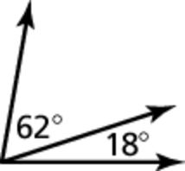 6. 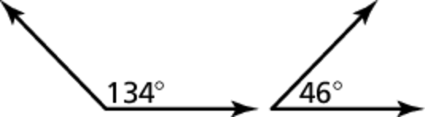

7. Angle *x* and angle *y* are complementary. Angle *x* is supplementary to   
a angle. What are the measures of angle *x* and angle *y*?

Tell whether the angles are *complementary* or *supplementary*. Then find the value of *x*.

8. 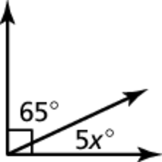 9. 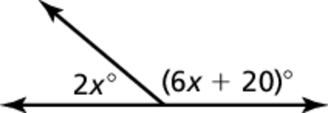

Draw a pair of adjacent supplementary angles so that one angle has the given measure.

10.  11.  12. 

13. Two angles have the same measure. What are their measures if they are also complementary angles? supplementary angles?

Name Date

Practice B

5.1

Practice B

7.2

Tell whether the angles are *complementary*, *supplementary*, or *neither*.

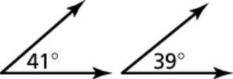 1. 2. 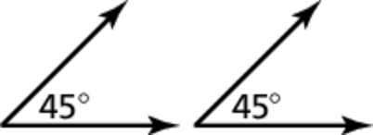

3. 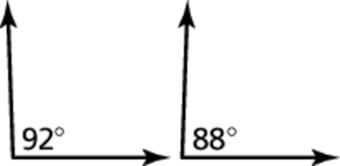 4. 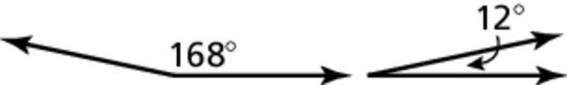

Tell whether the angles are *complementary* or *supplementary*. Then find the value of *x*.

5. 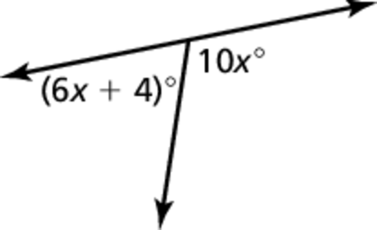 6. 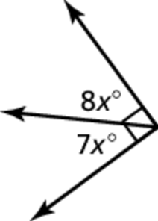

7. The measures of two supplementary angles have a ratio of 2 : 4. What is   
the measure of the smaller angle?

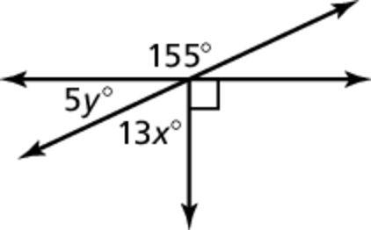 8. Find the values of *x* and *y*.

9. Letbe an angle measure. Let be the measure of the complement of the angle and letbe the measure of the supplement of the angle.

a. Write an equation involving

b. Write an equation involving