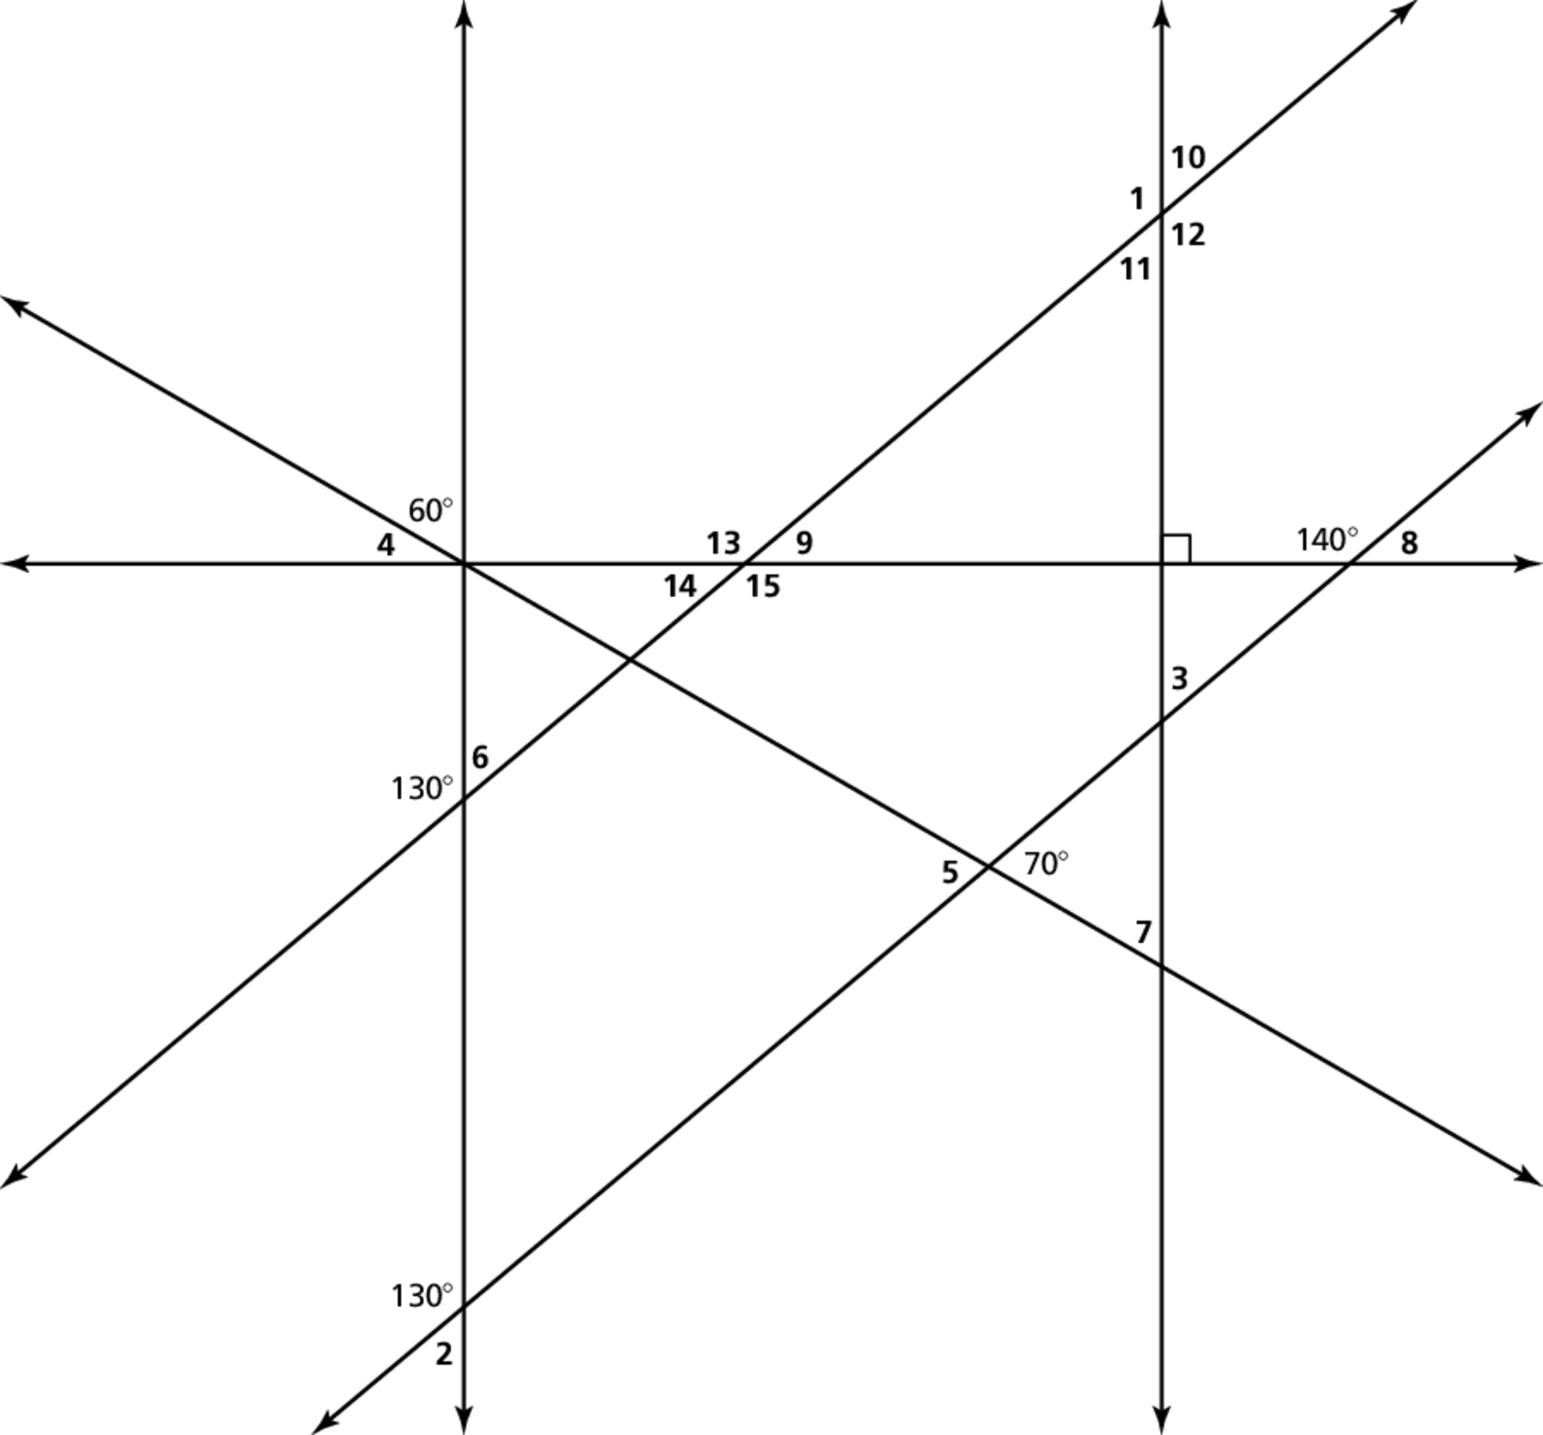
Name Date
Enrichment and Extension
7.2
Finding Missing Angles
Use properties of shapes and angles to find the missing measures.

