Name Date

7.1

puzzle

Puzzle Time

What Runs Around All Day And Lies Under The Bed With Its Tongue Hanging Out?

Write the letter of each answer in the box containing the exercise number.

Tell whether the angles are *adjacent* or *vertical*.

Answers

N. 29

K. vertical

A. 160

S. 60

E. adjacent

R. 135

E. adjacent

A. 110

1. 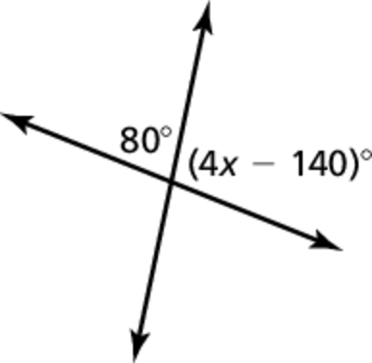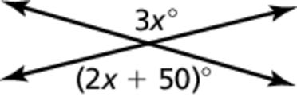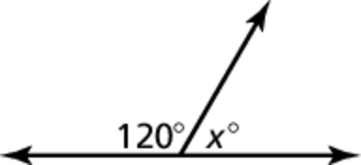 2.

3.

Find the value of *x*.

4. 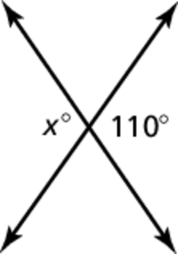 5. 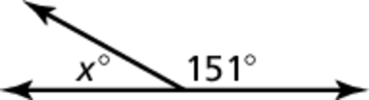

6. 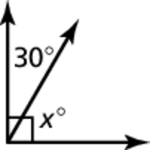 7. 

8. A road intersects another road   
at 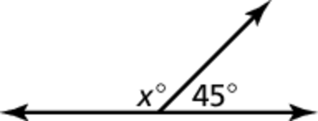an angle of  Find the   
value of *x*.

|  |  |  |  |  |  |  |  |  |
| --- | --- | --- | --- | --- | --- | --- | --- | --- |
| 7 |  | 6 | 5 | 3 | 4 | 2 | 1 | 8 |
|  |  |  |  |  |  |  |  |  |