Name Date

Practice A

7.1

Name two pairs of adjacent angles and two pairs of vertical angles in   
the figure.

1. 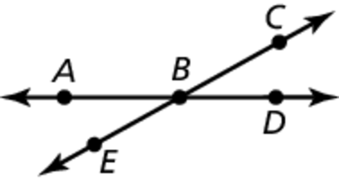 2. 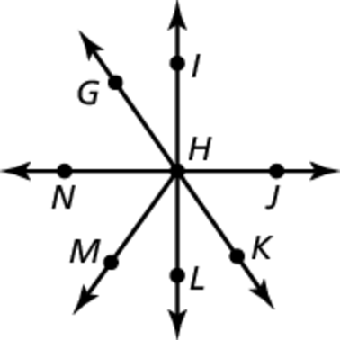

Tell whether the angles are *adjacent* or *vertical*. Then find the value of *x*.

3. 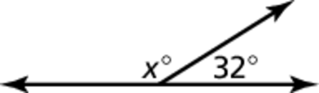 4. 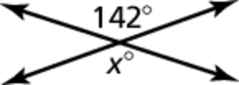

5. 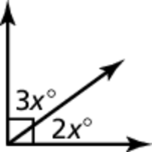 6. 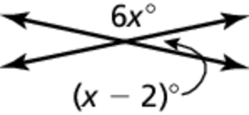

Draw a pair of vertical angles with the given measure.

7.  8.  9. 

10. Draw a pair of adjacent angles with the given description.

a. Both angles are obtuse.

b. The sum of the angle measures is 

c. The sum of the angles measures is 

11. What are the measures of the 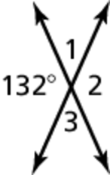  
other three angles formed by   
the intersection?

Name Date

Practice B

5.1

Practice B

7.1

Name two pairs of adjacent angles and two pairs of vertical angles in   
the figure.

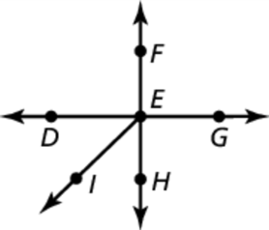 1. 2. 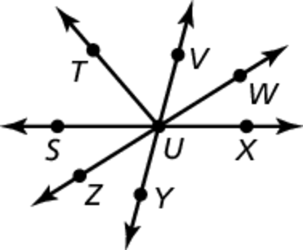

Tell whether the angles are *adjacent* or *vertical*. Then find the value of *x*.

3. 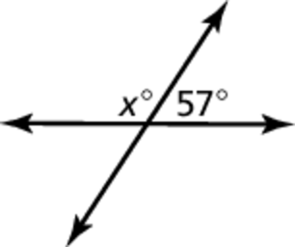 4. 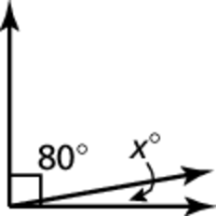

5. 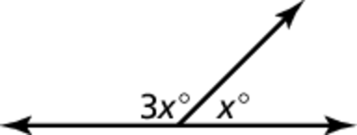 6. 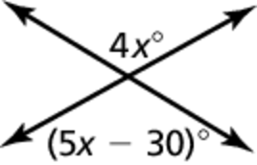

Draw a pair of vertical angles with the given measure.

7.  8.  9. 

10. Draw five angles so that are acute vertical angles, are supplementary, are complementary, and are adjacent.

11. The measures of two adjacent angles have a ratio of 3 : 5. The sum of the measures of the two adjacent angles is What is the measure of the larger angle?