Name Date
Enrichment and Extension
7.1
Compass Straightedge Construction
In addition to modern technology, a geometer’s most important tools are a compass and a straightedge (ruler without marks). These instruments can
be used for geometric drawings called constructions.
Bisecting the Angle
Bisecting the angle is the process of cutting a given angle in half so that both
halves are equal. This can be done using only a compass and straightedge.
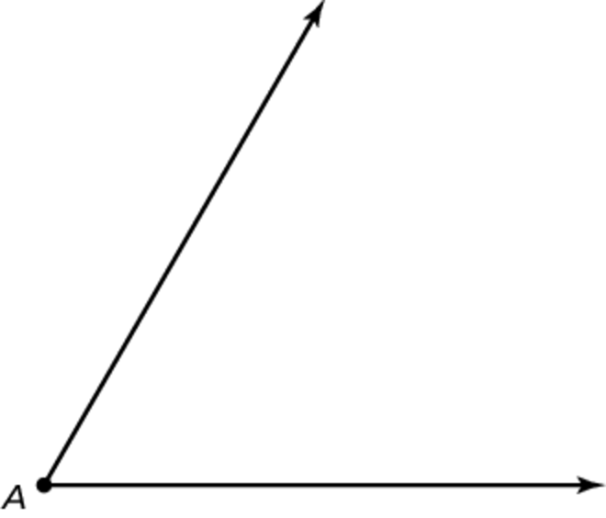

1. Classify angle A.
2. Open the compass. Place the point of the compass at A and draw an arc
(a small curved line that is part of a circle) that intersects both sides of
the angle. Label the points where the curved line intersects the angle as
B and C.
3. Place the point of the compass on B. Draw an arc that is contained within the angle. Without changing the width of the compass, place the point
of the compass on C and draw an arc that intersects the one just drawn.
4. Label the intersection point of the two arcs G. Use a straightedge to
connect points A and G. The line segment AG bisects angle BAC.
5. Use a protractor to measure angle BAC. Divide this measure by two to determine what each smaller angle should measure. Then, use your protractor and measure the smaller angles. How do the numbers compare?

