Name Date

Enrichment and Extension

6.3

Proportions and Similar Triangles

Triangles that have the same shape but not necessarily the same size are called **similar triangles**. Two triangles are similar when corresponding side lengths   
are proportional and corresponding angles are congruent.

**Example:** The triangles are similar. Find *x*.

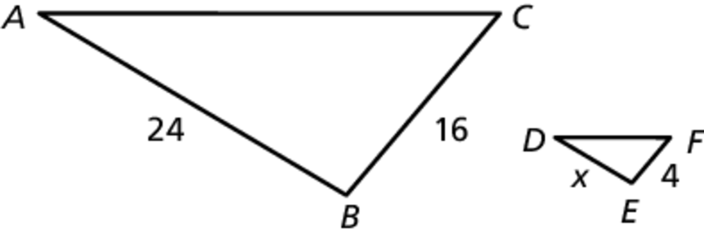

Triangle *ABC* Triangle *DEF*



So, 

The triangles are similar. Find *x*.

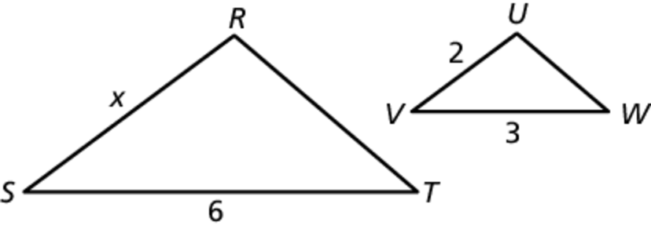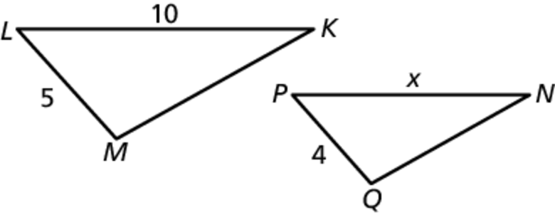 1. 2.

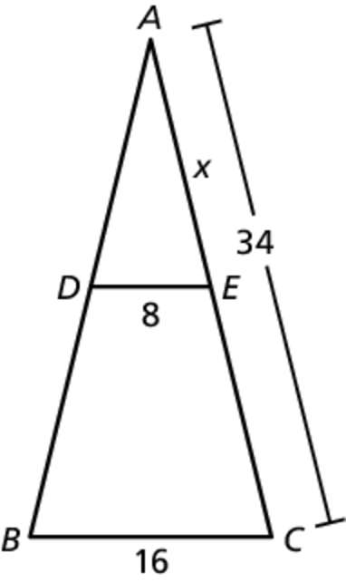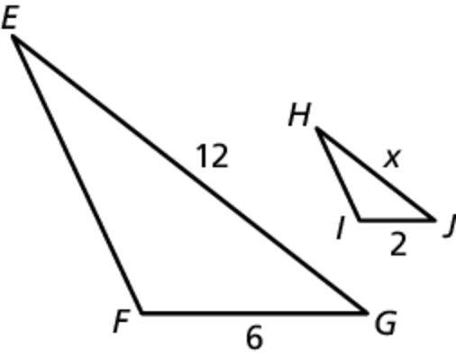 3. 4.