Name Date

Practice A

6.1

Write the percent as a decimal.

1. 81% 2. 78% 3. 5% 4. 8%

5. 40% 6. 60% 7. 23.7% 8. 16.75%

9. 150% 10. 210% 11. 186% 12. 416%

13. 100.8% 14. 5.17% 15. 0.4% 16. 0.04%

17. Describe and correct the error in writing 1.475% as a decimal.





Write the decimal as a percent.

18. 0.66 19. 0.32 20. 0.51 21. 0.97

22. 0.01 23. 0.04 24. 0.312 25. 0.468

26. 0.5 27. 1.2 28. 1.08 29. 1.16

30. 0.003 31. 0.025 32. 0.0245 33. 2.025

TA: R:\msfl6wb01.01\Gr 6 Production\Gr 6 Common Art\dec_arrow_2_blk.eps,11/13/2008 9:46:34 AM replaced: 7/31/2016 7:01:36 PM 34. Describe and correct the error in writing 1.8 as a percent.



35. Fifty-four percent of the students in your class have moved at least one time. Write this percent as a decimal.

36. Only 0.15 of the total number of vehicles in your school parking lot are buses. What percent of the vehicles are buses?

37. You spent 0.88 of your allowance this week. What percent of your allowance did you spend?

38. On a history test, you get 86 out of a possible 100 points. Write a decimal and a percent that represent a score of 86 out of 100.

39. Of the fluids that you drink on a typical day,is milk and 50% is water.   
How many times more water do you drink than milk?

Write the percent as a fraction in simplest form and as a decimal.

40. 21% 41. 75% 42. 64% 43. 85%

Name Date

Practice B

6.1

Write the decimal as a percent.

1. 0.54 2. 0.37 3. 0.222 4. 0.929

5. 1.4 6. 2.5 7. 20 8. 0.005

Write the percent as a fraction in simplest form and as a decimal.

9. 68% 10. 9% 11. 55% 12. 26%

13. 42.4% 14. 73.6% 15. 31.25% 16. 44.65%

17. About 36% of the students at a middle school are seventh graders.   
What percent are *not* in seventh grade?

18. The percents of three types of tickets collected at the gate for a   
high school football game are shown.

|  |  |  |  |
| --- | --- | --- | --- |
| Ticket type | Student | Adult | Senior (65 and older) |
| Percent | 48% | 28% | 14% |

a. Write the percents as decimals and as fractions.

b. There is one other type of ticket that is not shown. It is a ticket   
for a child under 5. What percent of the tickets were of this type?

c. Make a bar graph to represent the percents for all four ticket types.

**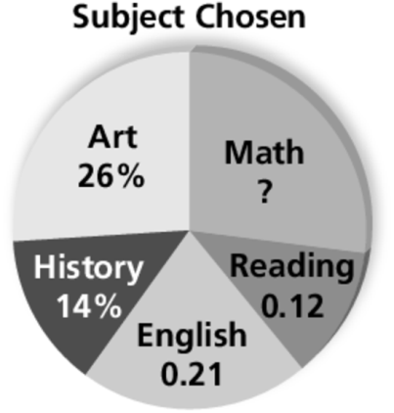** 19. Students in an after-school enrichment program chose one of five subject areas.

a. What percent chose English or reading?

b. What percent chose English or history?

c. How many times more students chose English   
than reading?

d. What percent chose math? Write the percent as a decimal.

20. At one school, half of the students live within 1 mile, 78% live within   
2 miles, and 0.1 of the students live between 2 and 3 miles from the school.

Make a table to show the percent of students who live at each distance from the school.

a. within 1 mile b. between 1 and 2 miles

c. between 2 and 3 miles d. more than 3 miles