Name Date
Enrichment and Extension
6.1
Playing Checkers
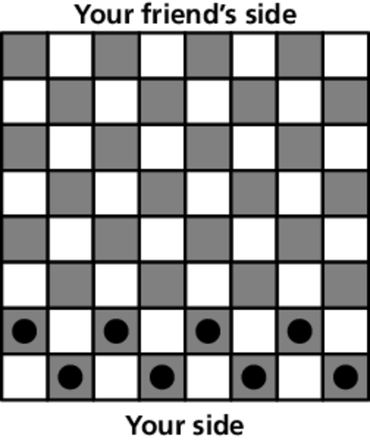
You set up a game of checkers as shown. Write a decimal for each percent you find.
1. What percent of the checker board is shaded?
2. What percent of the checker board is not shaded?
3. Your friend arrives and places pieces appropriately
on the board.
a. What percent of the checker board squares
have pieces?
b. What percent of the checker board squares do not have pieces?
c. What percent of the shaded checker board squares have pieces?
d. What percent of the shaded checker board squares do not have pieces?
4. At one point during the game, 4 of your pieces have been removed and
5 of your friend’s pieces have been removed.
a. What percent of the original number of pieces have been removed?
b. What percent of the original number of pieces are remaining?
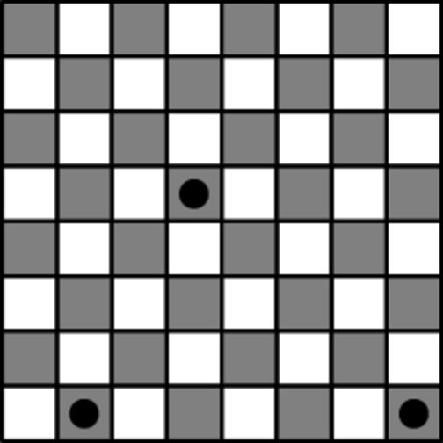
5. The checker piece near the middle of the board
can move diagonally in any direction between shaded squares.
a. On how many different squares can the piece be located at the end of on turn?
b. On how many different squares can the piece
be located at the end of two turns? What percent of the shaded checker board is this? Write this percent as a decimal.

