Name Date

Practice A

5.4

Use multiplication to solve the proportion.

1.  2.  3. 

Use the Cross Products Property to solve the proportion.

4.  5.  6. 

7. Eighteen oranges are packaged in 3 containers. How many oranges are packaged in 7 containers?

8. It costs $270 for 3 people to go on a fishing trip. How much does it cost for 10 people to go on the fishing trip?

Solve the proportion.

9.  10.  11. 

12. Tell whether the statement is *true* or *false*. Explain.

If , then .

13. The dimensions of a miniature model are proportional to the dimensions of the actual building.

a. A wall that is 12 feet high on the building is 36 centimeters high on the model. Find the height on the model of a door that is 9 feet high on the building.

b. Use a different method than the one you used in part (a) to find the number of centimeters on the model for a window that is 3 feet wide.

14. The ratio of men to women at a lecture is 2 to 5. A total of 63 people are at the lecture. How many are men? Explain how you found your answer.

|  |  |  |  |  |
| --- | --- | --- | --- | --- |
| **Feet** | 3 | *x* | 15 | *z* |
| **Seconds** | 5 | 65 | *y* | 3.5 |

15. The distance traveled (in feet) is proportional   
to the number of seconds. Find the values of   
*x*, *y*, and *z*.

16. You train for a race by running at a speed of 6 miles per hour.

a. At this speed, how many *minutes* does it take you to run 3.2 miles?

b. On race day, you run 3.2 miles in 30 minutes. What is your speed in miles per hour?

Name Date

Practice B

5.4

Use either multiplication or the Cross Products Property to solve the proportion.

1.  2.  3. 

4.  5.  6. 

7. Three shirts cost $9.99. How much does it cost for 8 shirts?

Solve the proportion.

8.  9.  10. 

11. The number of grams of protein is proportional to the number of servings.

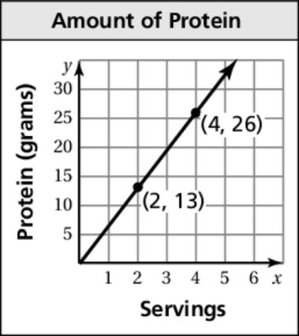 a. How many servings provide 32.5 grams   
of protein?

b. Use a different method than part (a) to   
find how many servings provide 52 grams   
of protein.

c. How many grams of protein will 7 servings   
provide?

d. If 1 serving is equal to  cup, how many   
cups does it take to get 19.5 grams of protein?

12. One day 176 people visited a small art museum. The ratio of members   
to nonmembers that day was 5 to 11. How many people who visited the museum that day were nonmembers?

13. Solve the proportion: .

14. One gallon of water weighs about 8.34 pounds.

a. How much does 3.5 gallons of water weigh?

b. One inch of rain on a square foot of land weighs 5.2 pounds. About how many gallons of rain are there? Round your answer to the nearest tenth.