Name Date

Practice A

5.1

Find the product. List the units.

1.  2.  3. 

Write the ratio as a fraction in simplest form.

4. 12 to 15 5. 24 : 9 6. 14 tetras : 6 angelfish

Find the unit rate.

7. 360 miles in 6 hours 8. 18 bowlers on 6 lanes 9. $28 for 7 people

Use the ratio table to find the unit rate with respect to the specified units.

10. Laps per minute 11. Grams of protein per serving

|  |  |  |  |  |
| --- | --- | --- | --- | --- |
| **Servings** | 0 | 1 | 2 | 3 |
| **Grams of Protein** | 0 | 15 | 30 | 45 |

|  |  |  |  |  |
| --- | --- | --- | --- | --- |
| **Minutes** | 0 | 2 | 4 | 6 |
| **Laps** | 0 | 1 | 2 | 3 |

12. At 9 a.m. you have run 2 miles. At 9:24 a.m. you have run 5 miles. What is your running rate in minutes per mile?

13. Are the two statements equivalent? Explain your reasoning.

* The ratio of orange to blue is 3 to 4.
* The ratio of blue to orange is 12 to 9.

14. There are 234 students in 9 different classrooms. What is the ratio of students to classrooms?

15. Dishwasher detergent is sold in individual packs. It is sold in 20-, 60-, and 90-pack containers.

a. Which container do you think has the lowest unit rate of dollars per pack? Why?

b. The 20-pack container sells for $5.49. What is the unit rate in dollars per pack? Round your answer to the nearest cent.

c. The 60-pack container sells for $10.97. What is the unit rate in dollars per pack? Round your answer to the nearest cent.

d. The 90-pack container sells for $18.95. What is the unit rate in dollars per pack? Round your answer to the nearest cent.

e. Which container has the lowest unit rate? How does this compare with your answer in part (a)?

Name Date

Practice B

5.1

Write the ratio as a fraction in simplest form.

1. 35 to 63 2. 10.8 seconds : 36 feet

3. 198 women to 110 men 4. 1000 songs : 2 megabytes

5. 26.1 miles : 3.6 hours 6. 12 completions to 28 attempts

Find the unit rate.

7. $5.40 for 24 cans 8. $1.29 for 20 ounces 9. 50 meters in 27.5 seconds

10. There are 16 bacteria in a beaker. Four hours later there are 228 bacteria in the beaker. What is the rate of change per hour in the number of bacteria?

11. The table shows nutritional information for three energy bars.

|  |  |  |  |  |
| --- | --- | --- | --- | --- |
| **Energy Bar** | **Calories** | **Protein** | **Fiber** | **Sugar** |
| A | 220 | 20 g | 12 g | 14 g |
| B | 130 | 12 g | 8 g | 10 g |
| C | 140 | 4 g | 9 g | 9 g |

a. Which has the most protein   
per calorie?

b. Which has the least sugar   
per calorie?

c. Which has the highest rate   
of sugar to fiber?

d. Compare bar A with bar B. Which nutritional item do you think has the highest ratio: calories, protein, fiber, or sugar?

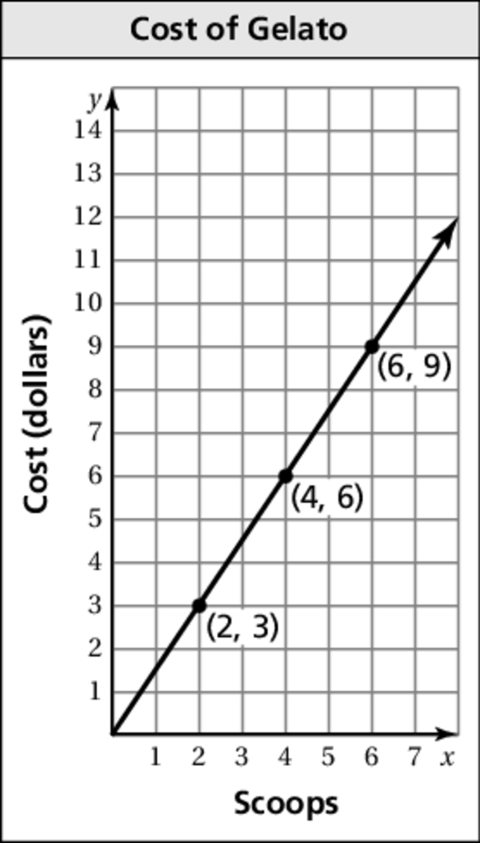 e. Calculate the ratios in part (d). Which one has the highest ratio?

12. The graph shows the cost of buying scoops of gelato.

a. What does the pointrepresent?

b. What is the unit cost?

c. What is the cost of 12 scoops?

d. Explain how the graph would change if the unit

rate was $1.75 per scoop.

e. How would the coordinates of the point in part (a)

change if the unit rate was $1.75 per scoop?

Write a situation for the ratio.

13.  14. 2 : 3