Name Date

Practice A

4.4

Solve the inequality. Graph the solution.

1.  2. 

3.  4. 

5. You are renting a moving truck for a day. There is a daily fee of $20 and a charge of $0.75 per mile. Your budget allows a maximum total cost of $65. Write and solve an inequality that represents the number of miles you can drive the truck.

Solve the inequality. Graph the solution.

6.  7. 

8.  9. 

10. Write and solve an inequality that represents the 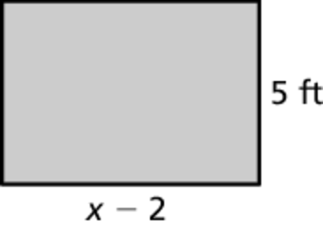  
values of *x* for which the area of the rectangle   
will be at least 35 square feet.

Solve the inequality. Graph the solution.

11.  12. 

13. Your weekly base salary is $150. You earn $20 for each cell phone that   
you sell.

a. What is the minimum amount you can earn in a week?

b. Write and solve an inequality that represents the number of cell phones you must sell to make at least $630 a week.

c. Write and solve an inequality that represents the number of cell phones you must sell to make at least $750 a week.

d. The company policy is that as a part-time employee, the maximum   
you can earn each week is $950. Write and solve an inequality that represents the number of cell phones you can sell each week.

Name Date

Practice B

8.4

Practice B

4.4

Solve the inequality. Graph the solution.

1.  2. 

3.  4. 

5. An RV park receives $300 per month from each residential site that is occupied as well as $2000 per month from their overnight sites. Write   
and solve an inequality to find the number of residential sites that must   
be occupied to make at least $14,000 in revenue each month.

Solve the inequality. Graph the solution.

6.  7. 

8.  9. 

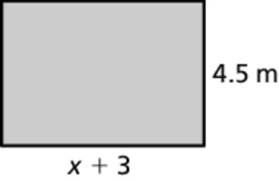 10. Write and solve an inequality that represents the   
values of *x* for which the area of the rectangle   
will be at most 45 square meters.

Solve the inequality. Graph the solution.

11.  12. 

13. An animal shelter has fixed weekly expenses of $750. Each animal in the shelter costs an additional $6 a week.

a. During the summer months, the weekly expenses are at least $1170. Write and solve an inequality that represents the number of animals   
at the shelter for expenses to be at least $1170 a week.

b. During the winter months, the weekly expenses are at most $900.   
Write and solve an inequality that represents the number of animals   
at the shelter for expenses to be at most $900 a week.

c. The cost for each animal has increased by $2. What will be the maximum weekly expenses during the winter months?