Name Date
Enrichment and Extension
4.3
Margin of Error
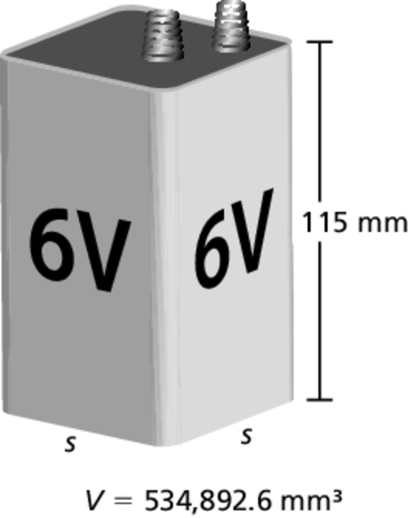
A 6-volt lantern battery has the given dimensions.
Any company that manufactures the batteries
must make sure their product meets the
specifications. The batteries are made
using machines. No machine is perfect and
so there will always be a slight variation of
the size of the batteries.
The allowable difference between the required
dimensions of the battery and its actual dimensions
is called the margin of error.
1. What is the ideal side length of the base of a 6-volt lantern battery?
2. The side length of the base of the battery has a margin of error of
0.002 millimeter. Write an inequality that models the margin of error e
of the base’s side length.
3. A margin of error in the side length will produce a margin of error in the volume of the battery.
a. What is the smallest side length allowed by the margin of error? What is the volume of a battery with this side length? Round your answer to the nearest thousandth.
b. What is the greatest side length allowed by the margin of error? What is the volume of a battery with this side length? Round your answer to the nearest thousandth.
c. Write an inequality that models the range of acceptable side lengths s of a battery.
d. Write an inequality that models the range of acceptable volumes V of a battery.
4. The side length of a battery is the value you calculated in Exercise 1 and
the height is 115.002 millimeters.
a. Find the volume of the battery. Round your answer to the nearest thousandth.
b. Which margin of error has a greater impact on the volume, the side length or the height? Why? Explain your reasoning.

