Name Date

Practice A

4.2

Solve the inequality. Graph the solution.

1.  2. 

3.  4. 

5.  6. 

7.  8. 

9. To stay within your budget, the area of the house and the garage combined is at most 3000 square feet. The area of the garage is 528 square feet. Write and solve an inequality that represents the area of the house.

10. You have $137.26 in a bank account. The bank requires you to have at least $50 in your account or else you are charged a fee. Write and solve an inequality that represents the amount you can write your next check for without being charged a fee.

Write and solve an inequality that represents *x*.

11. The perimeter is less than 20 meters. 12. The perimeter is at least 18 feet.

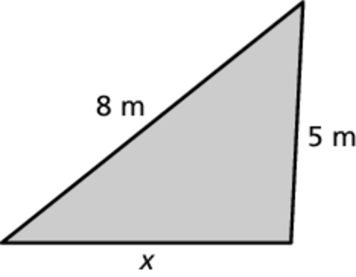

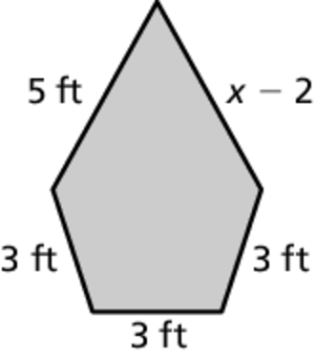

13. You need at least 5000 points to earn a gift card from your bank. You currently have 2700 points.

a. Write and solve an inequality that represents the number of points you need to earn a gift card.

b. You deposit money in your savings account and earn an additional   
400 points. How does this change the inequality?

Name Date

Practice B

4.2

Solve the inequality. Graph the solution.

1.  2. 

3.  4. 

5.  6. 

7.  8. 

9. You and two friends are diving for lobster. The maximum number of lobsters you may have on your boat is 18. You currently have 7 lobsters.

a. Write and solve an inequality that represents the additional lobsters that you may catch.

b. Another friend comes on your boat and he has 3 lobsters. You may now have 24 lobsters on your boat. Write and solve an inequality that represents the additional lobsters that you may catch.

c. How many lobsters is each person allowed to catch?

Write and solve an inequality that represents *x*.

10. The length is greater than the width. 11. The perimeter is less than   
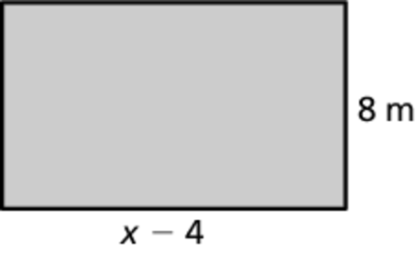 or equal to 50 in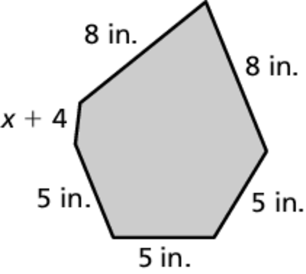ches.

12. The solution of  is  What is the value of *c*?

13. Describe all numbers that are solutions to 

14. The *triangle inequality theorem* states that the sum of the lengths of any two sides of a triangle is greater than the length of the third side. A triangle has side lengths of 6 inches and 17 inches. What are the possible values for the length of the third side? Explain how you found your answer.