Name Date

4.1

puzzle

Puzzle Time

What Do You Call A Bull That’s Sleeping?

Write t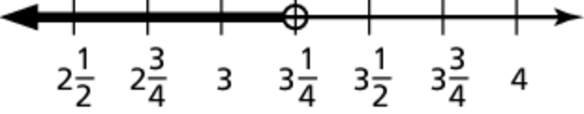h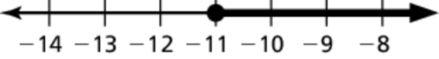e letter of e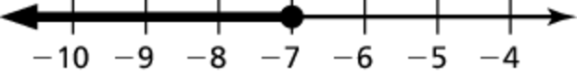ach answer in the box c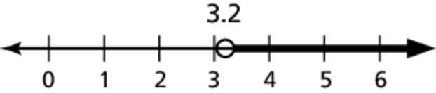ontaining the exercise number.

Write the word sentence as an inequality.

Answers

U. 

L. 

A.

D. yes

E. 

R.

L. 

Z.

B. no

O.

1. A number *x* is greater than 25.8.

2. Twice a number *x* is at most 

3. A number *x* minus 9.3 is more than 4.6.

4. A number *x* added to 11.7 is less than 14.

Tell whether the given value is a solution of   
the inequality.

5. 

6. 

Match each inequality with its graph.

7. 

8. 

9. 

10. 

|  |  |  |  |  |  |  |  |  |  |  |
| --- | --- | --- | --- | --- | --- | --- | --- | --- | --- | --- |
| 8 |  | 5 | 4 | 1 | 3 | 6 | 10 | 9 | 2 | 7 |
|  |  |  |  |  |  |  |  |  |  |  |