Name Date

Practice A

4.1

Write an inequality for the graph. Then, in words, describe all the values of *x* that make the inequality true.

1.  2. 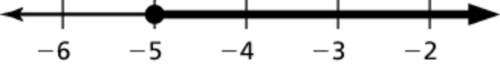

Write the word sentence as an inequality.

3. A number *x* is at most 3.

4. A number *y* added to 2 is greater than 7.

5. A number *c* multiplied by 3 is less than –12.

6. A number *m* minus 1.5 is no less than 2.

Tell whether the given value is a solution of the inequality.

7.  8. 

9.  10. 

Graph the inequality on a number line.

11.  12. 

13. In order to try out for one of the parts in a play at the local theater,   
you must be at most 12 years old. Write an inequality that represents   
this situation.

Tell whether the given value is a solution of the inequality.

14.  15. 

16. Consider the inequalities  and .

a. Is  a solution to both inequalities?

b. Is  a solution to both inequalities?

c. Find another value of *x* that is a solution to both inequalities.

Name Date

Practice B

8.1

Practice B

4.1

Write an inequality for the graph. Then, in words, describe all the values   
of *x* that make the inequality true.

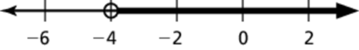 1. 2. 

Write the word sentence as an inequality.

3. A number *x* is at least 15.

4. A number *r* added to 3.7 is less than 1.2.

5. A number *h* divided by 2 is more than 

6. A number *a* minus 8.2 is no greater than 12.

Tell whether the given value is a solution of the inequality.

7.  8. 

9.  10. 

Graph the inequality on a number line.

11.  12. 

13. To get a job at the local restaurant, you must be at least 16 years old.   
Write an inequality that represents this situation.

Tell whether the given value is a solution of the inequality.

14.  15. 

16. In order to qualify for a college scholarship, you must have acceptable scores in either the SAT or the ACT along with the following requirements: a minimum GPA of 3.5; at least 12 credits of college preparatory academic courses; and at least 75 hours of community service.

a. Write and graph three inequalities that represent the requirements.

b. Your cousin has a GPA of 3.6, 15 credits of college preparatory class, and 65 hours of community service. Other than the test scores, does your cousin satisfy the requirements? Explain.