Name Date

Practice A

3.5

Solve the equation. Check your solution.

1.  2.  3. 

4.  5.  6. 

7.  8.  9. 

10.  11.  12. 

In Exercises 13–15, write an equation. Then solve.

13. It costs $4 to enter the fair. Each ride costs $2.50. You have $21.50. How many rides can you go on?

14. The cable company charges a monthly fee of $45. Each movie rental is $1.99. You owe $68.88. How many movies did you rent?

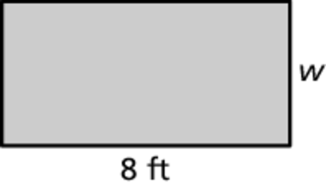 15. The perimeter of the rectangle is 24 feet.   
What is the width of the rectangle?

Solve the equation. Check your solution.

16.  17.  18. 

19. The senior class has 412 students. They are assigned to different homerooms. There are 28 students in the smallest homeroom and the remaining 12 homerooms have the same number of students. How many students are in each of the remaining 12 homerooms?

20. You purchased paint for the rooms in your house. You have  cans of   
paint left. You painted 4 rooms and each room required 2 cans of paint.   
You spilled  of a can of paint. How many cans of paint did you purchase?

a. Solve the problem by working backwards.

b. Solve the equation  How does the answer compare to   
part (a)?

Name Date

Practice B

3.5

Solve the equation. Check your solution.

1.  2.  3. 

4.  5.  6. 

7.  8.  9. 

10.  11.  12. 

In Exercises 13 and 14, write an equation. Then solve.

13. You purchased $132.49 worth of wheels and bearings for your skateboards. The shop charges $15 per board to install them. The total cost is $192.49. How many skateboards will be repaired?

14. A music download service charges a flat fee each month and $0.99 per download. The total cost for downloading 27 songs this month is $42.72. How much is the flat fee?

Solve the equation. Check your solution.

15.  16.  17. 

18. The perimeter of a triangle is 60 feet. One leg is 12 feet long. Of the two unknown sides, one of them is twice as long as the other. Find the lengths of the two unknown sides.

19. Sally picks seashells by the seashore. She lost 17 of them on her way home. She planned to fill 5 jars with the same amount of seashells in each. How many seashells did Sally pick?

a. You do not have enough information to solve this problem. The number of seashells in each jar is the same as the number portion of her street address, which is a 2-digit number. The first digit is 5. The last digit is   
9 less than 3 times the first digit. How many seashells did Sally plan to put in each jar?

b. By working backwards, determine how many seashells Sally picked.

c. The 5 jars that Sally chose would not each hold that many seashells.   
In her search for a 6th jar, she discovered a few seashells in her pocket. What are possible values for the number of seashells in each of the   
6 jars and the number of seashells discovered in her pocket, such that there are no seashells left over?