Name Date

Practice A

3.3

Solve the equation. Check your solution.

1.  2.  3. 

4.  5.  6. 

7.  8.  9. 

10.  11.  12. 

Write the word sentence as an equation. Then solve.

13. 5 more than a number *y* is 

14. The sum of 8 and a number *h* is 12.

15.  is 4 less than a number *n*.

In Exercises 16–20, write an equation. Then solve.

16. You earn $9 per hour babysitting. This is $2 more than what you earned per hour last year. What did you earn per hour last year?

17. Your mother asked you to turn the oven down to 325°F. This is 75°F less than it was. What was the original temperature?

18. The difference between the heights of your chair and your desk is   
 inches. The height of your desk is  inches. What is the   
height of your chair?

19. Your Two-Day-Pass to a theme park is $76.50. This is $31.41 less than your uncle’s Two-Day-Pass. What is the price of your uncle’s pass?

20. The perimeter of a triangle is 25 feet.   
What is the length of the unknown side?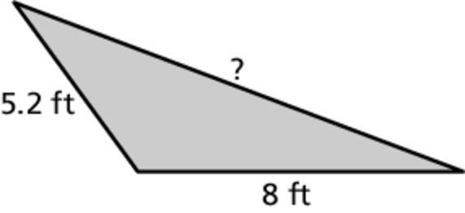

21. Find the value of  when 

Name Date

Practice B

3.3

Solve the equation. Check your solution.

1.  2.  3. 

4.  5.  6. 

7.  8.  9. 

10.  11.  12. 

Write the word sentence as an equation. Then solve.

13. 27 is  more than a number *x*.

14. The difference of a number *p* and  is 12.

15. 35 less than a number *m* is 

In Exercises 16–18, write an equation. Then solve.

16. You swim the 50-meter freestyle in 28.12 seconds. This is 0.14 second  
less than your previous fastest time. What was your previous fastest time?

17. The perimeter of a rectangular backyard is  meters. The two shorter sides are each  meters long. What is the length of the two longer sides? (*Hint*: The sum of the shorter side and the longer side is equal to half of   
the perimeter.)

18. The temperature of dry ice is  which is 183.6°F less than the outside temperature. What is the outside temperature?

19. Your cell phone bill in August was $61.43, which was $21.75 more than your bill in July. Your cell phone bill in July was $13.62 less than your bill in June. What was your cell phone bill in June?

Find the values of *x*.

20.  21. 