Name Date

Practice A

3.2

Find the sum.

1.  2. 

3.  4. 

5.  6. 

7.  8. 

9. After a week of rain, tadpoles appeared in your pond. After *t* minutes, you have (7*t* + 5) tadpoles and your friend has (8*t* – 3) tadpoles.

a. Write an expression that represents the number of tadpoles you and your friend caught together.

b. Who has more tadpoles after 9 minutes?

Find the difference.

10.  11. 

12.  13. 

14.  15. 

16. The admission to a local fair is $10 for each adult and $6 for each child. Each rides costs $1.50 for an adult and $1 for a child.

a. Write an expression that represents how much more an adult will spend at the fair.

b. An adult and a child each go on 7 rides. How much more did the adult spend?

17. Write an expression that represents 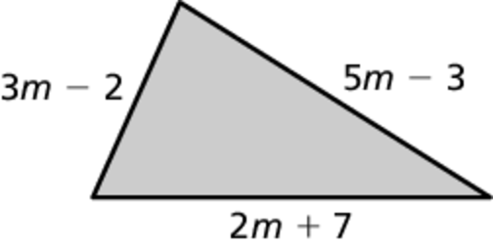  
the perimeter of the triangle.

Name Date

Practice B

3.2

Find the sum.

1.  2. 

3.  4. 

5.  6. 

7.  8. 

9. You are selling tickets to a play. You have sold tickets for $5 each and tickets for $7 each.

a. Write an expression that represents the total number of tickets sold   
so far.

b. Write an expression that represents the total amount of money received for the tickets that have been sold.

c. When **what is the total amount of money received?

Find the difference.

10.  11. 

12.  13. 

14.  15. 

16. You are collecting pairs of socks and toothbrushes for a local charity. After   
*d* days, you have collected pairs of socks and toothbrushes.

a. Write an expression that represents the total number of items that have been collected.

b. How many more pairs of socks than toothbrushes have been collected on day 7?