Name Date

Practice A

3.1

Identify the terms and like terms in the expression.

1. 

2. 

3. 

Simplify the expression.

4.  5. 

6.  7. 

8.  9. 

10.  11. 

12. Write an expression in simplest form that represents the perimeter of the polygon.

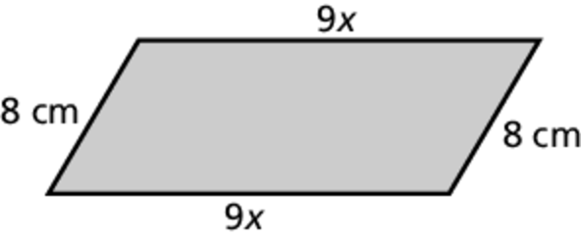

13. Each runner is carrying an 8 ounce bottle of water, a 2.1 ounce energy bar, and a 3 ounce energy drink. Write an expression in simplest form that represents the weight carried by *y* runners. Interpret the expression.

14. John weighs 65 kilograms, Sam weighs  kilograms, and Mark weighs  kilograms. Write an expression in simplest form for their combined weight.

15. Are the expressions  and  equivalent? Explain your reasoning.

Name Date

Practice B

3.1

Identify the terms and like terms in the expression.

1.  2. 

Simplify the expression.

3.  4. 

5.  6. 

7.  8. 

9. Write an expression in simplest form that represents   
the perimeter of the polygon.

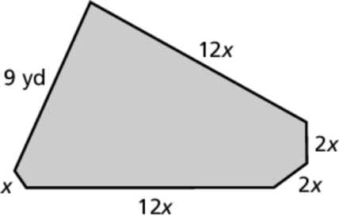

Draw a diagram that shows how the expression can represent the area of a figure. Then simplify the expression.

10.  11. 

12. Danielle is  years old. Her sister is 5 years older and her brother is half   
Danielle’s age. Write an expression in simplest form for the sum of their ages.

13. The length of a rectangular field is 30 more than twice its width. Write an expression in simplest form for the perimeter of the field in terms of its width w.

14. You buy x packs of pencils, twice as many 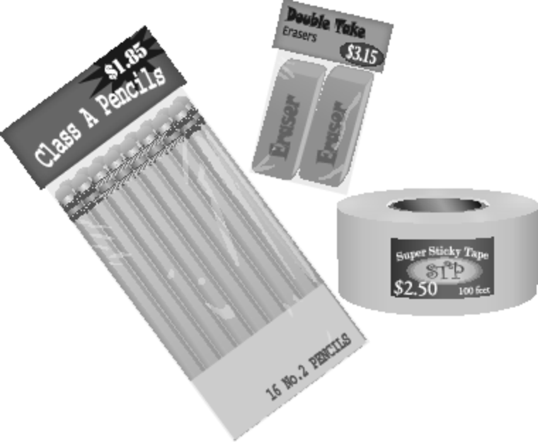  
packs of erasers, and three times as many   
rolls of tape. Write an expression   
in simplest form for the total   
amount of money you spent.