Name Date

Enrichment and Extension

2.3

Adding and Subtracting Numbers

Use the information to label the total change.

1. In golf, each hole has a par, or the amount of strokes it should take   
to complete the hole. Find the total number of strokes above or   
below par the golfer shot after the first six holes golfing.

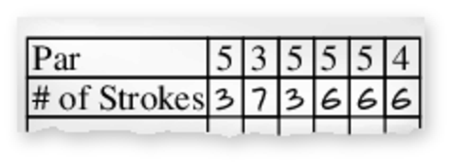

2. Find the amount of money left in the account.

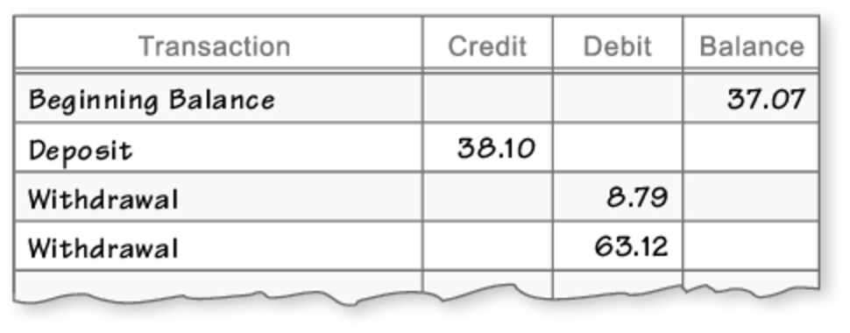

3. Find the total number of yards the football team gained or lost.

First down: Loss of 17 yards

Second down: Gain of 5 yards

Third down: Gain of 9 yards

Fourth down: Gain of 1 yard

Determine if the situation would result in a *positive number*, a *negative number* or *zero*. Explain.

4. Your bank account has a balance of $111.13. You write a check for $113.10.

5. You walk to your friends’ house then back home. Your friend lives   
 of a mile away.

6. The temperature at the beginning of the day was Fahrenheit. The temperature dropped Fahrenheit.

7. You cut a piece of wood into a -foot piece and a -foot piece.   
The original length of the board was 6 feet.