Name Date

Enrichment and Extension

2.1

Where do I Belong?

An **irrational number** is a decimal that goes on forever and does not repeat. Irrational numbers cannot be written as fractions.

**Examples:** 

A **real number** is any number that is either rational or irrational.

The Venn diagram shows how real numbers, rational numbers, irrational numbers, integers, and whole numbers are related.

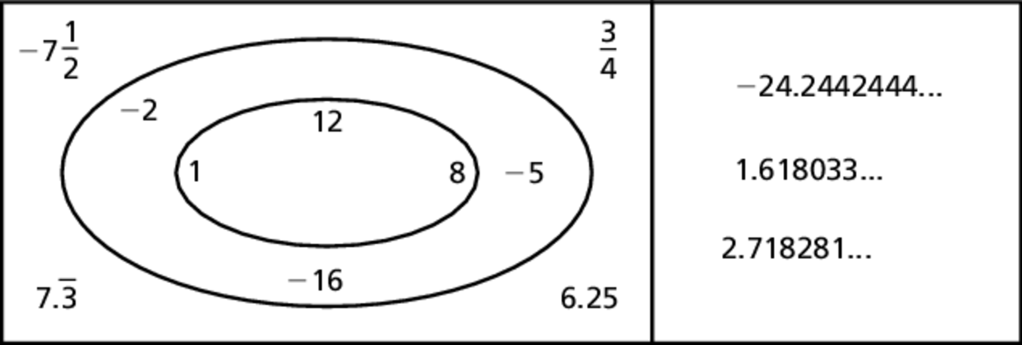

1. Describe any patterns you notice with the numbers.

2. Place the name of each number type in its appropriate spot.

Real number Rational number Irrational number Integer Whole number

For each real number, tell whether it is *rational*, *irrational*, an *integer*, and/or a *whole number*. You may have more than one answer.

3.  4.  5. 0.919911… 6. 15

7. Can you write 2 as a fraction? Are all whole numbers also rational numbers?

8. Can you write  as a fraction? Are all integers also rational numbers?

Complete the statement with *always, sometimes,* or *never*.

9. A **real number** chosen at random is  an **integer**.

10. An **integer** chosen at random is  a **real number**.

11. An **irrational number** chosen at random is  a **rational number**.

12. A **rational number** chosen at random is  an **integer**.

13. A **whole number** chosen at random is  a **rational number**.