Name Date
Enrichment and Extension
10.5
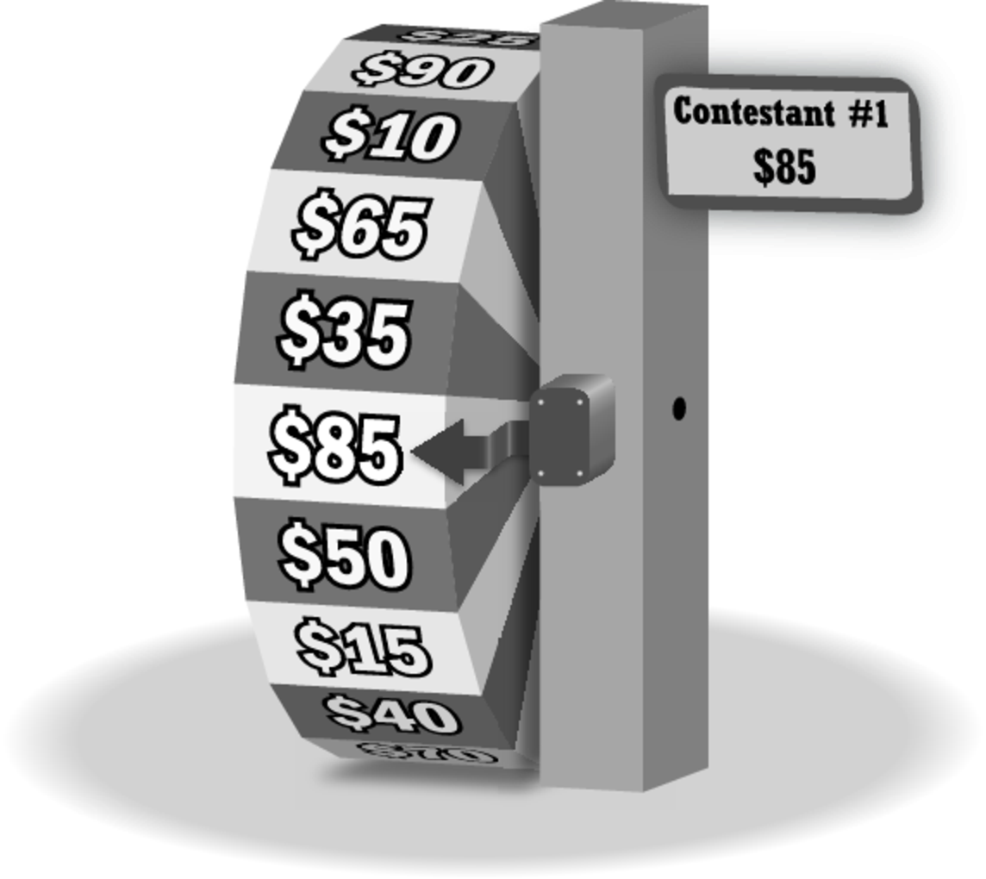
Winning on a Game Show
You are on a game show. You are spinning a
wheel that has 20 sections, ranging from $5 to
$100 in increments of $5. You win by spinning
more points than your opponent in one spin
or a combination of two spins. But, you lose
if you exceed $100.
Your opponent spins $85 in one spin and decides not to spin again.
1. What is the probability that you tie your opponent on the first spin?
2. How many values on the wheel
are greater than $85? What is the
probability that you win on your
first spin?
3. How many values on the wheel are less than $85? What is the probability that you spin less than your opponent on your first spin?
4. You spin $35 on your first spin.
a. What values on the wheel would make you win on your second spin?
b. What is the probability that the wheel lands on a winning section on your second spin?
5. You spin $60 on your first spin.
a. What values on the wheel would make you win on your second spin?
b. What is the probability that the wheel lands on a winning section on your second spin?
6. What do you notice about the probabilities in Exercises 2, 4(b), and 5(b)? Explain any similarity.
7. You spin less than $85 on your first spin. What is the probability that the wheel lands on a winning section on your second spin?
Your opponent’s score is given. (a) Find the probability that you win after one spin. (b) Find the probability that you spin a lesser amount on your first spin, and then win on your second spin.
8. $75 9. $45 10. $90 11. $25

