Name Date
Practice A
10.2
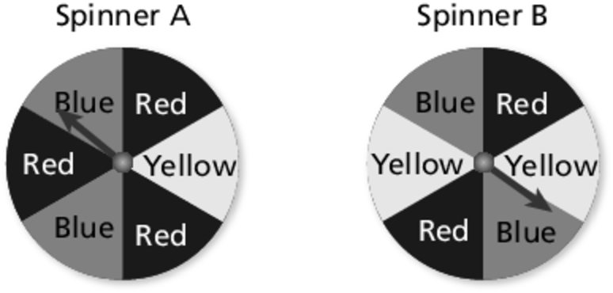
You are playing a game using the spinners shown.
1. You want to spin red. Which spinner should
you spin? Explain.
2. You want to spin yellow. Which spinner should
you spin? Explain.
3. You want to spin blue. Does it matter which spinner
you spin? Explain.
Describe the likelihood of the event given its probability.
4. The probability that it will snow today is zero.
5. You make a free throw 70% of the time.
6. Your band marches in of the parades.
You randomly choose one song from a collection of 4 country songs, 2 jazz songs, 3 rock songs, and 1 pop song. Find the probability of the event.
7. Choosing a jazz song
8. Choosing a pop song
9. Not choosing a country song
10. Choosing a blues song
11. Your football team has a 75% chance of winning a game. Your team is scheduled to play 16 games. Estimate how many games your team will win.
12. In a classroom, the probability that the teacher chooses a boy from 20 students
is 0.45.
a. How many students are not boys?
b. Describe the likelihood of not choosing a boy.
13. A box contains ten slips of paper numbered 1 through 10. Find the probability and describe the likelihood of each event.
a. Choosing a number greater than 2
b. Choosing a number that is a multiple of 2
c. Choosing a number that is less than 10
Name Date
Practice B
10.2
Describe the likelihood of the event given its probability.
1. The school bus arrives late of the time.
2. The probability that it rains during a hurricane is 1.
3. There is an 85% chance that you will go to the concert.
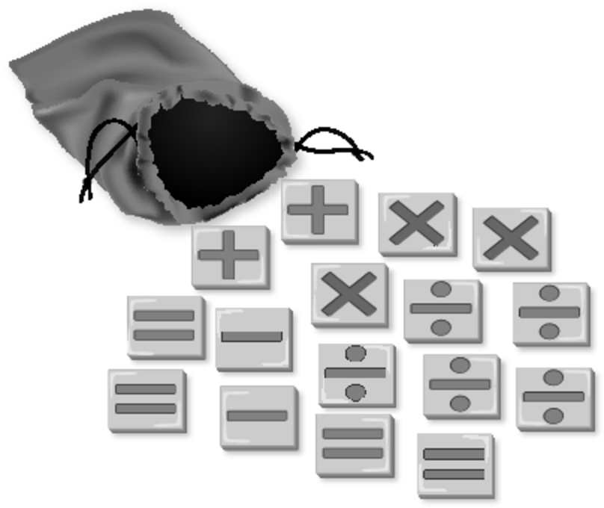
You randomly choose one mathematical operator from the collection.
Find the probability of the event.
4. Choosing a multiplication sign
5. Choosing a plus sign
6. Not choosing an equal sign
7. Not choosing a greater than sign

8. One-half of the boxes of cereal contain a prize.
a. Find the probability of winning a prize.
b. Find the probability of not winning a prize.
c. If you purchased two boxes of cereal, estimate the number of prizes you would receive.
9. A store has 30 blue pens, 18 black pens, and 12 red pens in stock. You buy 3 blue pens, 9 black pens, and 3 red pens. Find the probability of each event before and after your purchase. Then describe how your purchase affects the probability of each event.
a. Randomly choosing a blue pen
b. Randomly choosing a black pen
c. Randomly choosing a red pen

