Name Date

Enrichment and Extension

10.2

Geometric Probability

Assume that a dart thrown at the target is equally likely to hit anywhere   
on the target. The probability *P* that the dart lands in the shaded region   
is  Find the probability that the dart lands in the shaded region.

1. 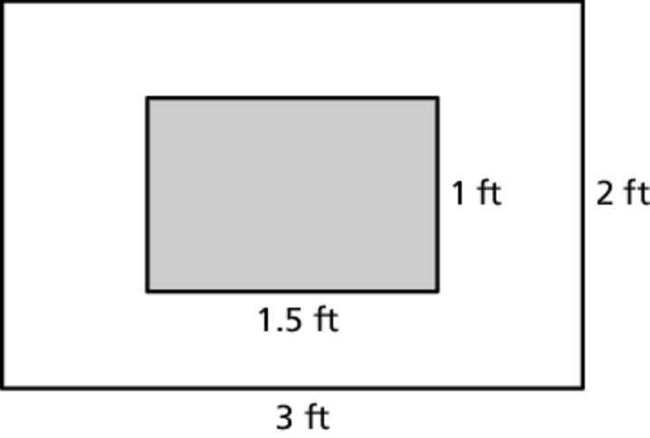 2. 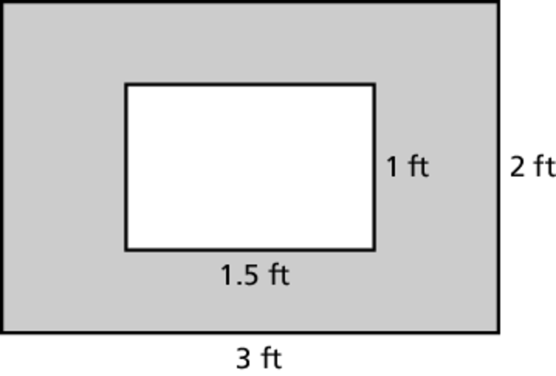

3. 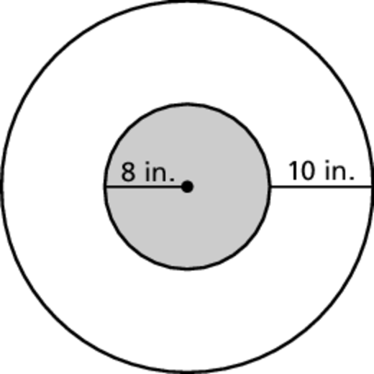 4. 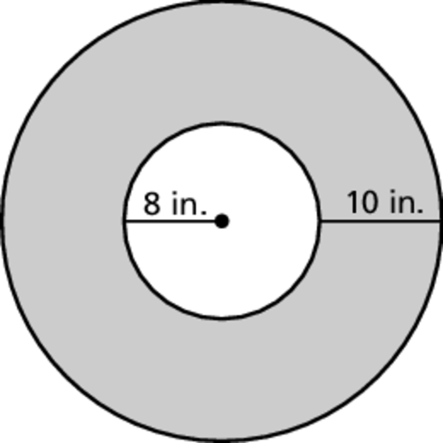

5. 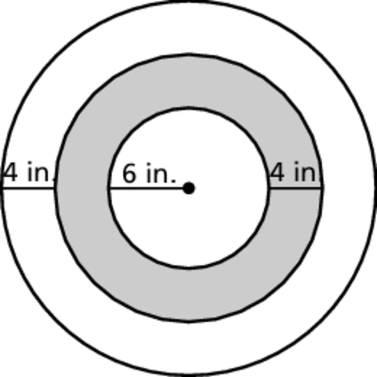 6. 