Name Date

Enrichment and Extension

1.5

Absolute Value and Integers

Assume  and  Determine whether the statement is *always, sometimes,* or *never* true.

1.  2.  3  4. 

5.  6.  7.  8. 

9.  10.  11.  12. 

13.  14.  15.  16. 

Assume *a*, *b*, and *n* are integers, with  and  Determine whether the possible values of *n* are *all integers, all positive integers and zero, all negative integers and zero,* or *none.*

17.  18.  19.  20. 

21.  22.  23.  24. 

25.  26.  27.  28. 

29.  30.  31.  32. 

For each exercise number, use your 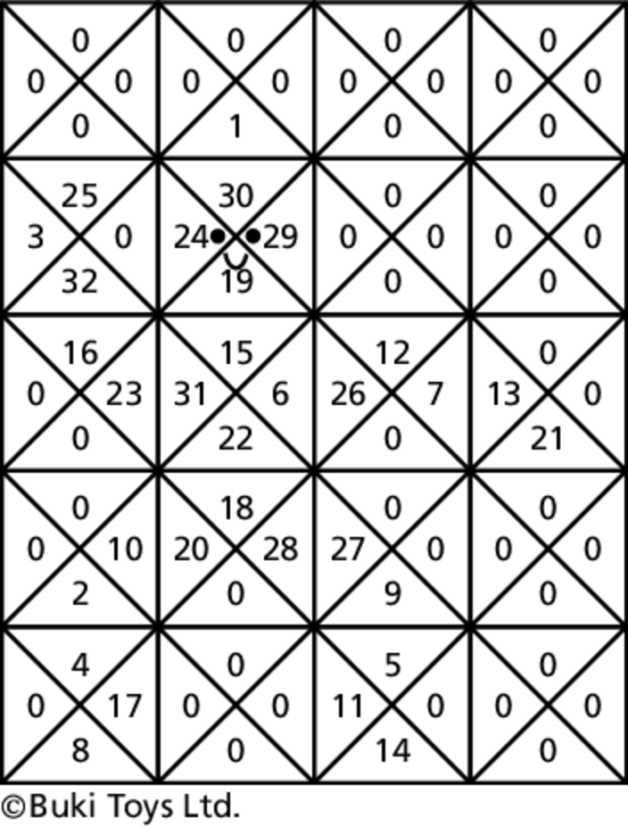  
answers and the key below to color   
the cell. Do not color the cells that   
have a zero in them.

Always  Purple

Sometimes  Blue

Never  Red

All Integers  Blue

All Positive Integers and Zero  Orange

All Negative Integers and Zero  Red

None  Purple